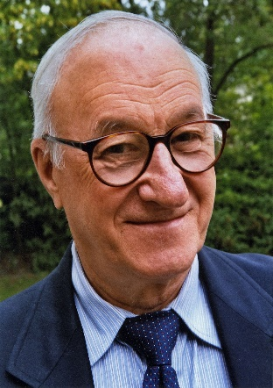

Albert Bandura – known for his Bobo Doll experiment, social learning theory, and concept of self-efficacy.

In contrast to Skinner, Bandura believed classical and operant conditioning were inadequate as a framework and **believed many human behaviors are learned from other humans**.

For example, in the Bobo doll experiments, children who observed an adult hitting and yelling at an inflatable doll, called Bobo, were more likely to display aggressive behavior toward the doll when playing with it later. **The Bobo Doll studies demonstrated that children learn from watching adult behavior and suggested that televised violence can teach and glamorize aggressive behavior.** The findings of the experiments upended the established behavioral doctrine that learning was a conditioned response to external punishments and rewards.

Bandura proposed social learning theory, which emphasizes the importance of observing, modeling, and imitating the behaviors, attitudes, and emotional reactions of others. He also emphasized the following two ideas:

1. Mediating processes occur between stimuli & responses.
2. Behavior is learned from the environment through the process of observational learning (e.g. the Bobo doll experiments).

In 1986, Bandura changed social learning theory to social cognitive theory (which is used extensively in education). The social cognitive theory explains how behavior and growth are affected by the cognitive operations that occur during social activities. The key theoretical components of the social cognitive theory that are applied in education are self-efficacy, self-regulation, observational learning, and reciprocal determinism.

Bandura’s research actually shows how motivation can be applied to learning. When teachers and students believed they could reach their goals, they were more likely to reach those goals (self-efficacy).