[Teacher blogs](http://www.edweek.org/tm/section/blogs/index.htmll) > Coach G's Teaching Tips See our [Teacher News Coverage](http://www.edweek.org/ew/topics/teachers/index.html)

[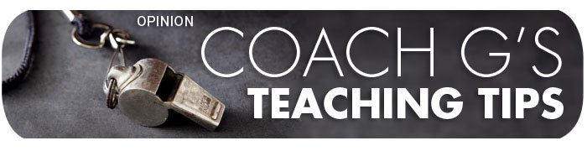](http://blogs.edweek.org/teachers/coach_gs_teaching_tips/)

**David Ginsburg has served over 20 years as a math teacher, instructional leader, and PD provider. He leads a Philadelphia-based team of consultants that specializes in instructional coaching, leadership coaching, and common-core implementation. Follow David on** [**Twitter**](https://twitter.com/CoachGinsburg)**, and connect with him through** [**email**](mailto:david@ginsburgcoaching.com) **and** [**LinkedIn**](https://www.linkedin.com/in/davidginsburg1)**.**

**Four Keys to Effective Classroom Learning Centers**

By [David Ginsburg](http://blogs.edweek.org/teachers/coach_gs_teaching_tips/) on February 28, 2016 8:24 PM

*I'm pleased to publish this guest post by my colleague Alison Stumacher, who served 10 years as an elementary educator in and around Philadelphia, and now supports schools as a consultant specializing in instructional coaching. You can contact her at*[*astumacher@gmail.com*](mailto:astumacher@gmail.com)*.*

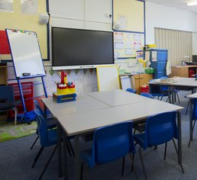

The chime signifying the start of centers was a highlight for me in my third grade classroom. As the sound faded, students dispersed to the guided reading table, computer bank, tables at the front of the room, and the rug. Our center routines had become sacred after rehearsing them for weeks until students knew where to go, how to get there, what to do when they arrived, and who they would be working with.

But centers did not always look this way in my classroom.

As a new teacher, I had a vague notion that I should use learning centers in my classroom. I had heard the term "centers" often and knew other teachers were using them. But I didn't know what qualified as a center or how often I was supposed to implement them.

I also didn't know what students were supposed to get out of centers. Practice and review old skills? Learn new skills? Blow off steam and learn through play? If nothing else, Isaw centers as a chance to divide my class into small groups, which I believed would be easier to manage. But each week, I scrambled to put together centers activities (usually involving lots of paper), spent lots of time redirecting students, and was unsure what, if anything, students were learning from the experience.

Lacking clarity and purpose, I believed I was "doing centers" as long as students were in small groups or working on different tasks. I used worksheets that weren't engaging or differentiated. I failed to assess the effectiveness of centers and hold students accountable for the work. I grouped students by convenience (e.g., by table) rather than with intention. I neglected to teach students procedures related to centers including how to get there, what materials to use and how to use them, and what students should do if they need help. And I tried to reinvent the wheel each week, by constantly preparing new centers materials.

Eventually, though--after reflecting critically on my classroom practices, asking colleagues for advice, and attending workshops--I transformed my centers from chaos to order, and from busywork to meaningful learning tasks. Here are four keys to effective learning centers that allowed me to make this transformation:

1. **Create, communicate, and practice procedures.** Centers involve a complex choreography of diverse students, areas, and materials. Teachers must create comprehensive procedures, communicate them to students, and allow adequate time to practice them until they become routine.
2. **Group with intention:** Centers allow students to work in different configurations including independently, in groups they choose based on interest, and in mixed ability or leveled groups. In all cases, grouping decisions must be intentional, based on the nature and purpose of each activity.
3. **Provide meaningful tasks:** Centers tasks in any content area should be interesting, challenging, and when possible, provide students a chance to practice skills in authentic ways--meaning that activities help students connect their learning to the real world or develop real-life habits of mind. For example, having students navigate the classroom library to choose books and read independently, write for a variety of purposes (letters, blogs, scripts, ads, or news articles), or play math games that help develop mental math strategies.
4. **Assess the impact.** Whether by observing students as they're working, collecting student work to review, or engaging students in reflections on their learning, teachers must monitor student progress. It's important to know when students need support or scaffolding and when they need to be challenged further.

With these measures in place, I no longer wondered what students were supposed to get out of centers. I could see for myself every time I rang the chime. And now, as an instructional coach, I continue to see the benefits of centers. When implemented well, centers enable students to interact in a relaxed setting, and empower them to navigate the learning environment on their own and in diverse groups. Well-chosen centers activities accommodate different learning styles, and allow students to self-direct as they apply skills and strategies in fun, engaging ways. And finally, centers allow teachers to address the distinct needs of small groups of students.

*Image by liquoricelegs, provided by Dreamstime license*

***Join my*** [***mailing list***](http://visitor.r20.constantcontact.com/d.jsp?llr=6ddjqzkab&p=oi&m=1111104982141&sit=rhnkqhihb&f=95cd5345-f062-49df-bc65-efd10483affd) ***for announcements about the work I* do to improve teaching and learning.**