|  |  |
| --- | --- |
| **Describe the event you are planning:** | **Which type(s) of involvement does this event target?** *(see handout)*  ⃝ Parenting  ⃝ Communicating  ⃝ Volunteering  ⃝ Learning at Home  ⃝ Decision-Making  ⃝ Collaborating with the Community |
| **How will you know if your event has enhanced family & community involvement?** | |

**People:** *Your Action Team*

|  |  |  |  |  |
| --- | --- | --- | --- | --- |
| **Team Members** | **Who?** *(be specific!)* | **How will they be involved?** | **How will they be a resource?** | **What benefits will they gain by participating?** |
| School personnel |  |  |  |  |
| Family members |  |  |  |  |
| Community partner(s) |  |  |  |  |

**Activities:** *What You’ll Do*

|  |  |  |  |  |
| --- | --- | --- | --- | --- |
| **Activity** | **Who?** | **How activity will draw on funds of knowledge** | **Resources Needed** | **How will results be evaluated?** |
|  |  |  |  |  |
|  |  |  |  |  |
|  |  |  |  |  |
|  |  |  |  |  |
|  |  |  |  |  |

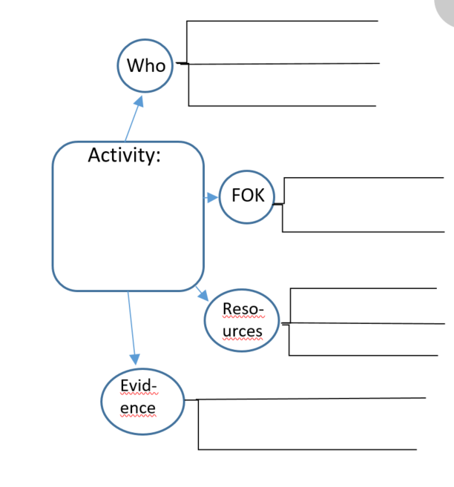

Evid-ence

Reso-urces

FOK

Activity:

Who

**Topic: ______________________________________________________**

|  |  |
| --- | --- |
| Academic Vocabulary | Discourse |
|  |  |

**Topic: ______________________________________________________**

|  |  |
| --- | --- |
| **Literacy/ELA** | **Math** |
|  |  |
| **Social Studies** | **Science** |
|  |  |

|  |  |  |
| --- | --- | --- |
|  | **Family Members** | **Community Partners** |
| Who?  be specific) |  |  |
| Their role(s) |  |  |
| Other | Funds of knowledge: | Benefits to them: |

|  |  |
| --- | --- |
| **Academic Vocabulary** | **Discourse** |
|  |  |