- Space Data Information

The Design Consultant shall submit the following Space Data Information for all Project renovations and new construction projects:

- Space/Room Number (refer to the University of Kentucky room numbering standards)

- Space Function (examples: Office, Lab, Janitor Closet, Corridor)

- Space Net Square Feet (length x width, inside to inside of wall)

The Space Data Information shall be submitted to the Capital Project Management Division with the Phase 3; Construction Documents. The Capital Project Management division shall forward the submitted information to the Medical Center Facilities Planning & Resource Management Office.

The Space Data Information shall be submitted digitally both for CAD architectural floor plans and in excel format.

- Submittal – CAD format Architectural floor plans / Key Drawings

The Space Data Information shall be included on the architectural floor plans. Each space/room and circulation space on the floor plans must include the above listed data. The minimum acceptable scale for the plans shall be 1/16” = 1’- 0”.

The Design Consultant shall submit of the architectural floor plans with the required Space Data information. On New Construction or Major Renovations (where a renovation exceeds 50% of the floor) provide CAD Drawings of each floor. Each floor shall be in a separate files and each floor level shall be further broken down by separate layers for each of the following: columns, doors, elevation change/roof below, equipment/ mechanical, walls, grid, misc., outline, restroom fixtures, stairs/elevators/ramps/ladders, text with room #/building & floor names, windows, square footage) of the new / reconfigured space. UK will require one digital PDF and one DWG file format floor plan set.

- Submittal - Digital Files

The Space Data Information shall be submitted digitally in the UK provided template. Instructions provided in EXCEL workbook on Instructions tab.

- Template Location: http://www.uky.edu/cpmd/design-standards/division-00---procurement-and-contracting-requirements-group 003150S03 SpaceData.xlsm
- Information required includes:
  - Project name and number listed at the top of the spreadsheet.
  - Space Data Information with headings:
    - Space/Room Number
    - Space Function
    - Space Net Square Feet.
- The space data shall be listed in separate columns with the headings as listed in the provided EXCEL template.
- Example GSF information from EXCEL template, GSF tab:

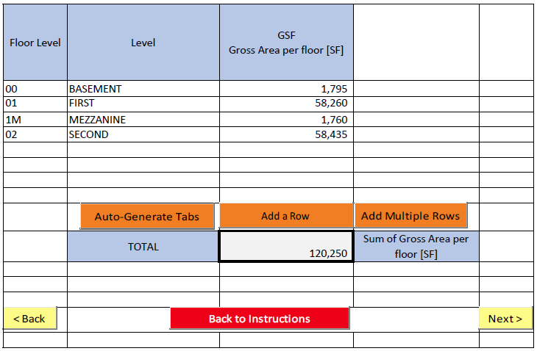

- Example Floor Level chart from EXCEL template [partial]:
  - Provide one chart per level
