University of Kentucky

Communications And Network Systems

Telecommunications Standards

Revision 5.0
June 2011

1.0 Revision Notes 5
2.0 Communications and Network Systems 6
Division Guidelines 6
Contact List 6
3.0 CODES, STANDARDS AND REGULATIONS 7
Overview 7
Agencies 7
4.0 COmmonly Used Symbols 8
5.0 GLOSSARY AND ACRONYMS 9
6.0 OUTSIDE PLANT 10
Introduction 10
Cable-General 10
Abandoned Cables 10
Cable Types Allowed 10
Service Entrance Conduit 11
General 11
Allowable Conduit Types 11
Minimum Requirements 11
Underground Ductbanks 12
General Requirements 12
Duct Bank Envelope 12
Ductbank Inspection 13
Drainage of Ductbanks 13
Marking Requirements 13
Using Tunnels 13
FIGURE 1 - Spacers For Communications Ductbanks 14
FIGURE 2 – Ductbank Detail 15
MANHOLES 16
General 16
Interiors 16
Cables and Labeling 16
FIGURE 3 - Communications Manhole Cross Section 17
FIGURE 4 - Construction Details – Communications Manhole 18
7.0 TelECOMMUNICATIONS ROOMS 19
Definition 19
Requirements 19
General Requirements 19
Telecommunications Room Sizing 20
Environmental Control 20
Electrical Requirements 21
Termination Hardware 21
Labeling 22
FIGURE 5 – Telecommunications Room Layout 23
FIGURE 6 – Rack Elevation 24
8.0 Optical FIBER TECHNOLOGY 25
General 25
Minimum Fiber Qualities 25
Minimum Requirements OSP Fiber Optic Cable 25
Fiber Physical Performance 26
Optical Fiber Cable Installation 26
Outside Plant (Infrastructure Cables) 26
Inside Plant (Riser Cables) 27
General 27
9.0 Inside Plant 28
General 28
Backbone Cabling 28
Horizontal Cabling 28
Communications outlets 29
Locations and Quantities 29
Outlet Installation 30
10.0 horizontal pathways 31
General 31
Cable Support Systems 31
Conduit 31
Sleeves and Risers Error! Bookmark not defined.
Serving Communications Outlets 31
Conduit at Cable Trays and Wireways 32
Conduit Capacity 32
Cable Tray 32
Wireway 33
Underfloor Duct System 34
11.0 CATV & video 35
General 35
Video/Projection Devices, Cabling and Outlets 35
12. PrOTECTION, GROUNDING, AND BONDING 36
Lightning Protection 36
General 36
Materials 36
Grounding 36
Bonding 36
13. INSPECTION AND TESTING 37
Inspection of Work 37
Inspection - General 37
Testing 37
Testing - General 37
14. FIRE STOPPING 38
Appendix A 39
Approved Manufacturers 39
Appendix B 40
Parts Listing 40

1.0 Revision Notes

3.205 Added Smoke detector requirement to comm closet section

4.0 Corrected Page Numbering Problems

Correct verbiage, reorganize sections

Addendum for duct bank rebar #6 v #4 with 6" conc under

Change Manhole dimensions

CastInPlace Manholes

Add additional rebar to the bottom of the duct bank

Deleted, inserted & corrected drawings

Room wires are to be bundled and labeled at the rack as they are pulled in

Ground bar revised

5.0 Update Contacts

OSP Service entrance conduit quantity

Update cable outlet type

Update Horizontal Pathways

Telecommunications Room detail

Appendix A & B

2.0 Communications and Network Systems

Division Guidelines

Communications and Network Systems (CNS) has the responsibility for planning, developing, managing and maintaining the most effective, efficient and economical communications network system. In its role as a system integrator of networks, the Division supports all University needs by approving and coordinating all voice, data and video communications systems policies. With the convergence of voice, data and video technologies, the Division is committed to a seamless communications services network.

Contact List

A list of University contacts and telephone numbers is provided for your convenience.

COMMUNICATIONS AND NETWORK SYSTEMS
04 PARKING STRUCTURE NO. 2
LEXINGTON, KENTUCKY 40506-0198

Design and Engineering
Donna Schultz RCDD Infrastructure Engineer 859-257-9215

Joe Clary, Manager 859-218-0127

Outside Plant Cabling / Cable locating services
Stuart Conley 859-257-4586

CNS
Rob Tudor, Director 859-257-6416

Campus Data Trouble Desk 859-218-4357

CAPITAL PROJECT MANAGEMENT DIVISION
222 Service Building
Lexington, Kentucky 40506-0005 859-257-5911

MAIN CAMPUS PHYSICAL PLANT
211 Service Building
Lexington, Kentucky 40506-0005 859-257-2726

MEDICAL CENTER PHYSICAL PLANT
Kelly Building
Lexington, Kentucky 859-323-6281

OFFICE OF FIRE AND ACCIDENT PREVENTION
428 Columbia Avenue
Lexington, Kentucky 40506-0457 859-257-6326

3.0 CODES, STANDARDS AND REGULATIONS

Overview

To design facilities for an effective telecommunications system, the designer and installer must be familiar with national and local regulations. Both the designer and the contractor must be familiar with and adhere to the standards of the telecommunications and building industries.

Agencies

The following agencies and their codes, standards and regulations shall govern all telecommunications work performed at the University of Kentucky.
- ANSI American National Standards Institute
- BICSI Building Industry Consulting Services International
- BOCA Building Officials and Code Administrators (Standard Building Code)
- EIA Electronic Industries Association
- FCC Federal Communications Commission
- FOTP Fiber Optic Testing Procedures
- ICBO International Conference of Building Officials (Uniform Building Code)
- IEEE Institute of Electrical and Electronic Engineers, Inc
- NBC National Building Code
- NFPA National Fire Protection Association
- NEC National Electrical Code
- RUS Rural Utilities Services
- TIA Telecommunications Industry Association
- UL Underwriters Laboratories
- University of Kentucky Communications and Network Systems Standards

4.0 COmmonly Used Symbols

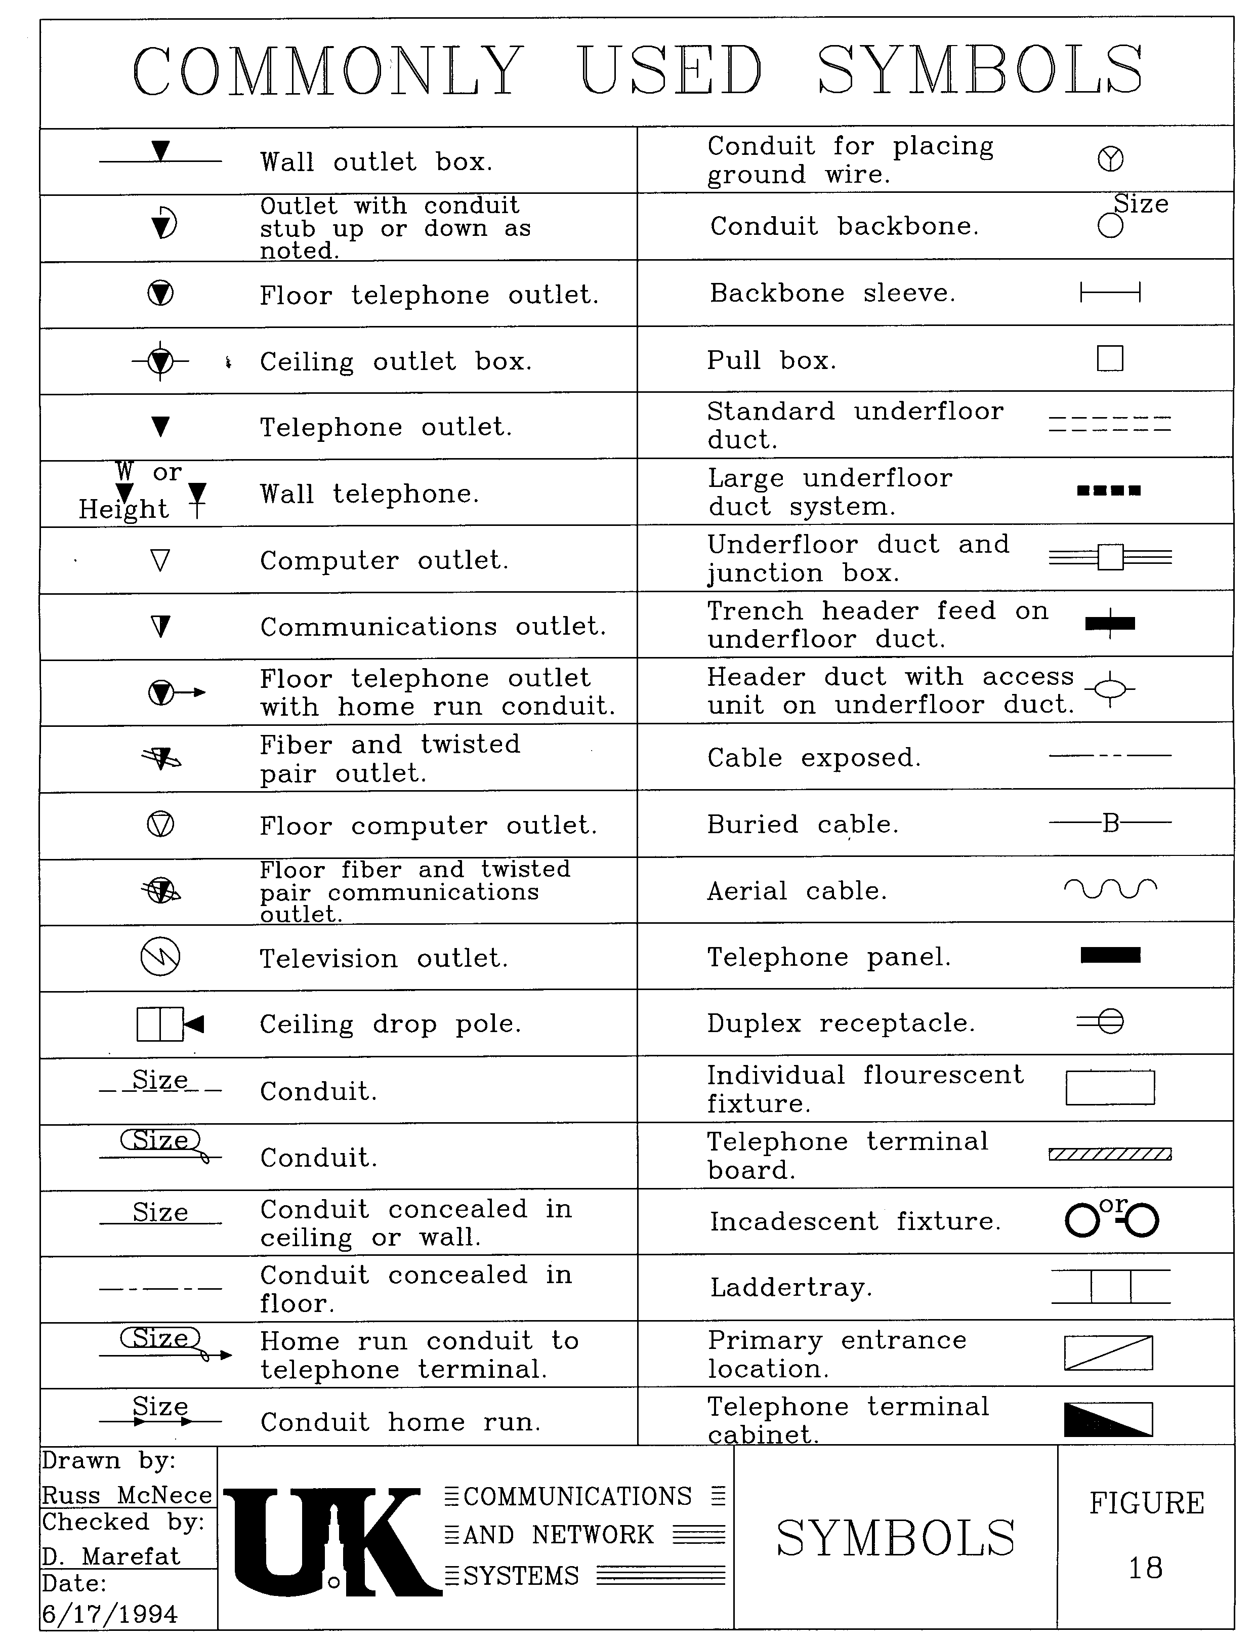

5.0 GLOSSARY AND ACRONYMS

AFF Above Finished Floor

AWG American Wire Gage

BDF Building Distribution Frame

CDF Combined Distribution Frame

CNS Communications & Network Systems

DOWELED Drilled hole for rebar

EMT Electrical Metallic Tubing

FC Foot-candle

HVAC Heating, Ventilation and Air Conditioning

Hz Hertz

IDF Intermediate Distribution Frame

KBC Kentucky Building Code

LAN Local Area Network

OHM Unit of resistance

OSP Outside Plant

PBX Private Branch Exchange

PPD Physical Plant Division, University of Kentucky

PVC Type of conduit

SF Square foot

TR Telecommunications Room

UK University of Kentucky

WAN Wide Area Network

6.0 OUTSIDE PLANT

Introduction

This section provides the necessary guidelines to install duct banks, manholes, service entrances to buildings, and information for the termination of cables entering buildings. All outside plant voice, data, and video cabling, conduit and manholes shall be designed and/or approved in writing by the University's Division of Communications and Network Systems (CNS).

UK Campus Physical Plant Division (PPD) and Medical Center Physical Plant (MCPPD) are responsible for their respective Energy Management Systems and Fire Alarm Systems.

Cable-General
Prior approval and coordination with CNS, PPD Manager of Utilities, and other concerned parties is necessary when the situation requires pulling cable through a conduit occupied by other cables. All cables associated with the campus telecommunications network (telephone, data, LAN, WAN, cable television and fiber optics) shall be connected and disconnected by CNS.

Only those cables specified within this document will be installed in any communications facility. There shall be no cable with voltages higher than 48 volts in communications duct banks except as follows. Electrical feeders for sump pumps, lights and outlets must be installed according to the National Electrical Code requirements for wet locations and shall be isolated in separate conduits. All copper cables entering a building shall be terminated on protection blocks. Only gas and solid state protectors shall be used.

Damages incurred to any cable are the responsibility of the party involved. All damages shall be reported immediately to CNS and PPD Manager of Utilities.

Abandoned Cables
Whenever possible, all abandoned cable shall be removed from tunnels, manholes, and conduit. If it is not feasible to remove abandoned cable, it shall be clearly tagged at both ends as abandoned, with appropriate labeling, and shall be reported to CNS and the PPD Manager of Utilities.

Cable Types Allowed
Most university low voltage cabling is installed underground in duct banks. No aerial cable shall be installed on campus unless approved by CNS, UK PPD Manager of Utilities, Capital Project Management and the campus architect. Information shall be obtained from CNS in reference to ownership of aerial cables and poles.

Service Entrance Conduit

General
Service Entrance conduit sizing and quantities between buildings shall be determined by CNS Design and Engineering. Minimum requirements are outlined in the following paragraphs.

When conduits pass through exterior concrete walls of any facility, the entrance shall be watertight. Wall sleeves at service entrance points must be sized to provide a minimum of ½ inch clearance around the conduit to allow for proper sealing of the penetration.

All campus buildings shall be connected to the nearest manhole or new manhole if one is to be installed.

Allowable Conduit Types
Gas pipe and water pipe shall not be used for conduit under any circumstances.

Two types of conduit are accepted for underground conduit systems.

- Rigid galvanized steel conduit with threaded fittings -- This conduit shall be installed with reinforced concrete casing. When not encased in concrete, conduit shall be painted with two coats of coal tar base paint or have an epoxy coating applied by manufacturer.
- Schedule 40 PVC conduit -- This conduit shall be installed with reinforced concrete casing. No PVC conduit is acceptable without reinforced concrete.

Direct burial of any conduits will not be permitted unless approved in writing by the Director of CNS Design and Engineering.

Minimum Requirements
All new facilities or major renovations will be required to meet minimum requirements. Minimum voice, data, and video conduit required to each building should be:

- Two (2) four-inch, Schedule 40, PVC and four (4) 1-1/4 inch quad Tel-Duct or equivalent (no outer sleeve),
- No more than the equivalent of two 90-degree sweeps are allowed in a run, including offsets. Absolutely no “LB’s” (elbows) allowed in any conduit route inside or outside plant.
- Some buildings may require connection to each other in addition to the service entrance conduit requirement.
- Buildings larger than 100,000 square feet shall have two means of access to the campus underground conduit system.

Underground Ductbanks

General Requirements
The layout of duct banks shall be generally parallel and perpendicular to property and building lines.

All conduit and ducts must be terminated with bell ends at the manhole, facility or other termination point. A nylon pull string will be installed and tied off in each conduit.

All underground conduits and ducts, rigid or PVC, installed shall be added in-multiples of two.

All underground conduits, duct banks and raceways shall be encased in steel reinforced, concrete (3500 psi minimum).

Additional reinforcement is to be used when crossing roadways.

All communications ducts shall be a minimum of twelve (12) inches from power duct banks or cables. All communications ducts shall also be a minimum of twenty four (24) inches from steam pipes and condensate lines if crossing perpendicular. When communication ducts run parallel to steam lines a minimum of a six (6) foot separation is required to avoid conduction of heat. All other duct separations must comply with the National Electric Code.

Rigid steel conduit, encased in reinforced concrete, shall be used in any location subject to unbalanced pressure, such as under slabs, roadways, driveways, or foundations.

All necessary precautions shall be taken by the contractor during construction to prevent the lodging of dirt, plaster or trash in all conduit, tubing, fittings and boxes. All conduits in floors, concrete or below grade shall be swabbed free of debris and moisture before wires are pulled.

Duct Bank Envelope
The duct envelope shall be sized and placed as shown on construction documents.

The duct envelope shall have a rectangular cross section and provide a minimum concrete thickness of three (3) inches on the top and sides of all conduits and six (6) inches at the bottom of the envelope (See Figure 1).

Reinforcing rebar rods shall be sized according to the number conduits in the ductbank envelope.
- Four (4) conduits – use #4 ( ½ ”) rebar
- Six (6) or more conduits – use #6 ( ¾ ”) rebar

A minimum of four (4) steel reinforcing rods shall be installed parallel to the conduit in all duct bank envelopes. Reinforce these rods with perpendicular rods in between the spacers (see Figure 1).

Duct spacers shall be provided at a maximum of seven (7) foot intervals. Large ductbanks with 12 or more conduits will require spacers installed at shorter intervals. CNS will provide requirements prior to installation.

Where conduits enter a building or a manhole the rebar must be doweled into the structure to prevent shearing of the conduits in case of settlement.

Where trench walls are unstable or the trench width is wider than the designed envelope, the envelope shall be formed as required.

Each duct run shall be installed with a continuous concrete pour. Broken pours are not allowed without written exception from CNS Design and Engineering. In the event of an approved broken pour the rebar will extend twenty four (24) inches beyond the end of the envelope and at all stub-outs at the end of each day's pour.

Ductbank Envelope, continued

A yellow coloring agent shall be added to the top three (3) inches of concrete used for underground communications ducts. The color agent is subject to CNS Design and Engineering approval.

Ductbank Inspection
All duct runs will be inspected and approved by CNS Engineering staff prior to pouring of concrete. At least twenty four (24) hour prior notice will be given to CNS that a pour will be taking place. Failure to obtain inspection and approval in writing will result in removal of ductbank.

Drainage of Ductbanks
Duct banks shall be pitched to drain toward manholes. All conduit, tubing, raceways, ducts and duct banks shall be installed in such manner to insure against collection of trapped condensation. Raceway runs shall be arranged to be void of traps.

When conduits pass through exterior concrete walls of any facility, the entrance shall be watertight. Wall sleeves at entrance points must be sized to provide a minimum of ½ inch clearance around the conduit to allow for proper sealing of the penetration.

All conduits shall have watertight connections and be sloped so they drain away from the building entrance. All empty conduit is to be sealed with the proper materials to prevent water drainage into the building.

Marking Requirements
Utility markers shall identify ALL conduit and ductbank routes. The type of marker and manufacturer shall be obtained from CNS and/or UK Capital Project Management. Utility markers shall conform to Capital Project Management’s Legend for Utility Markers. Prior approval and coordination with CNS, PPD Manager of Utilities, and other concerned parties is necessary when the situation requires any modification to the conduit system. The current source of utility markers is the Bruce Fox Co., 812-945-3111, New Albany, IN.

Damages incurred to any conduit are the responsibility of the party involved. All damages shall be reported to CNS and PPD Manager of Utilities immediately.

Using Tunnels
Where conduit or ducts are in installed in tunnels, they shall be kept at least twenty four (24) inches from parallel runs of flues, steam pipes, hot gas pipes, hot water pipes or any other utility line which becomes hotter than 120 degrees during normal operation of the facility it serves. All conduit sections crossing steam lines shall be threaded rigid and shall be provided with a means of thermal insulation from the steam lines, unless written exception is provided by UK Communications.

FIGURE 1 - Spacers For Communications Ductbanks
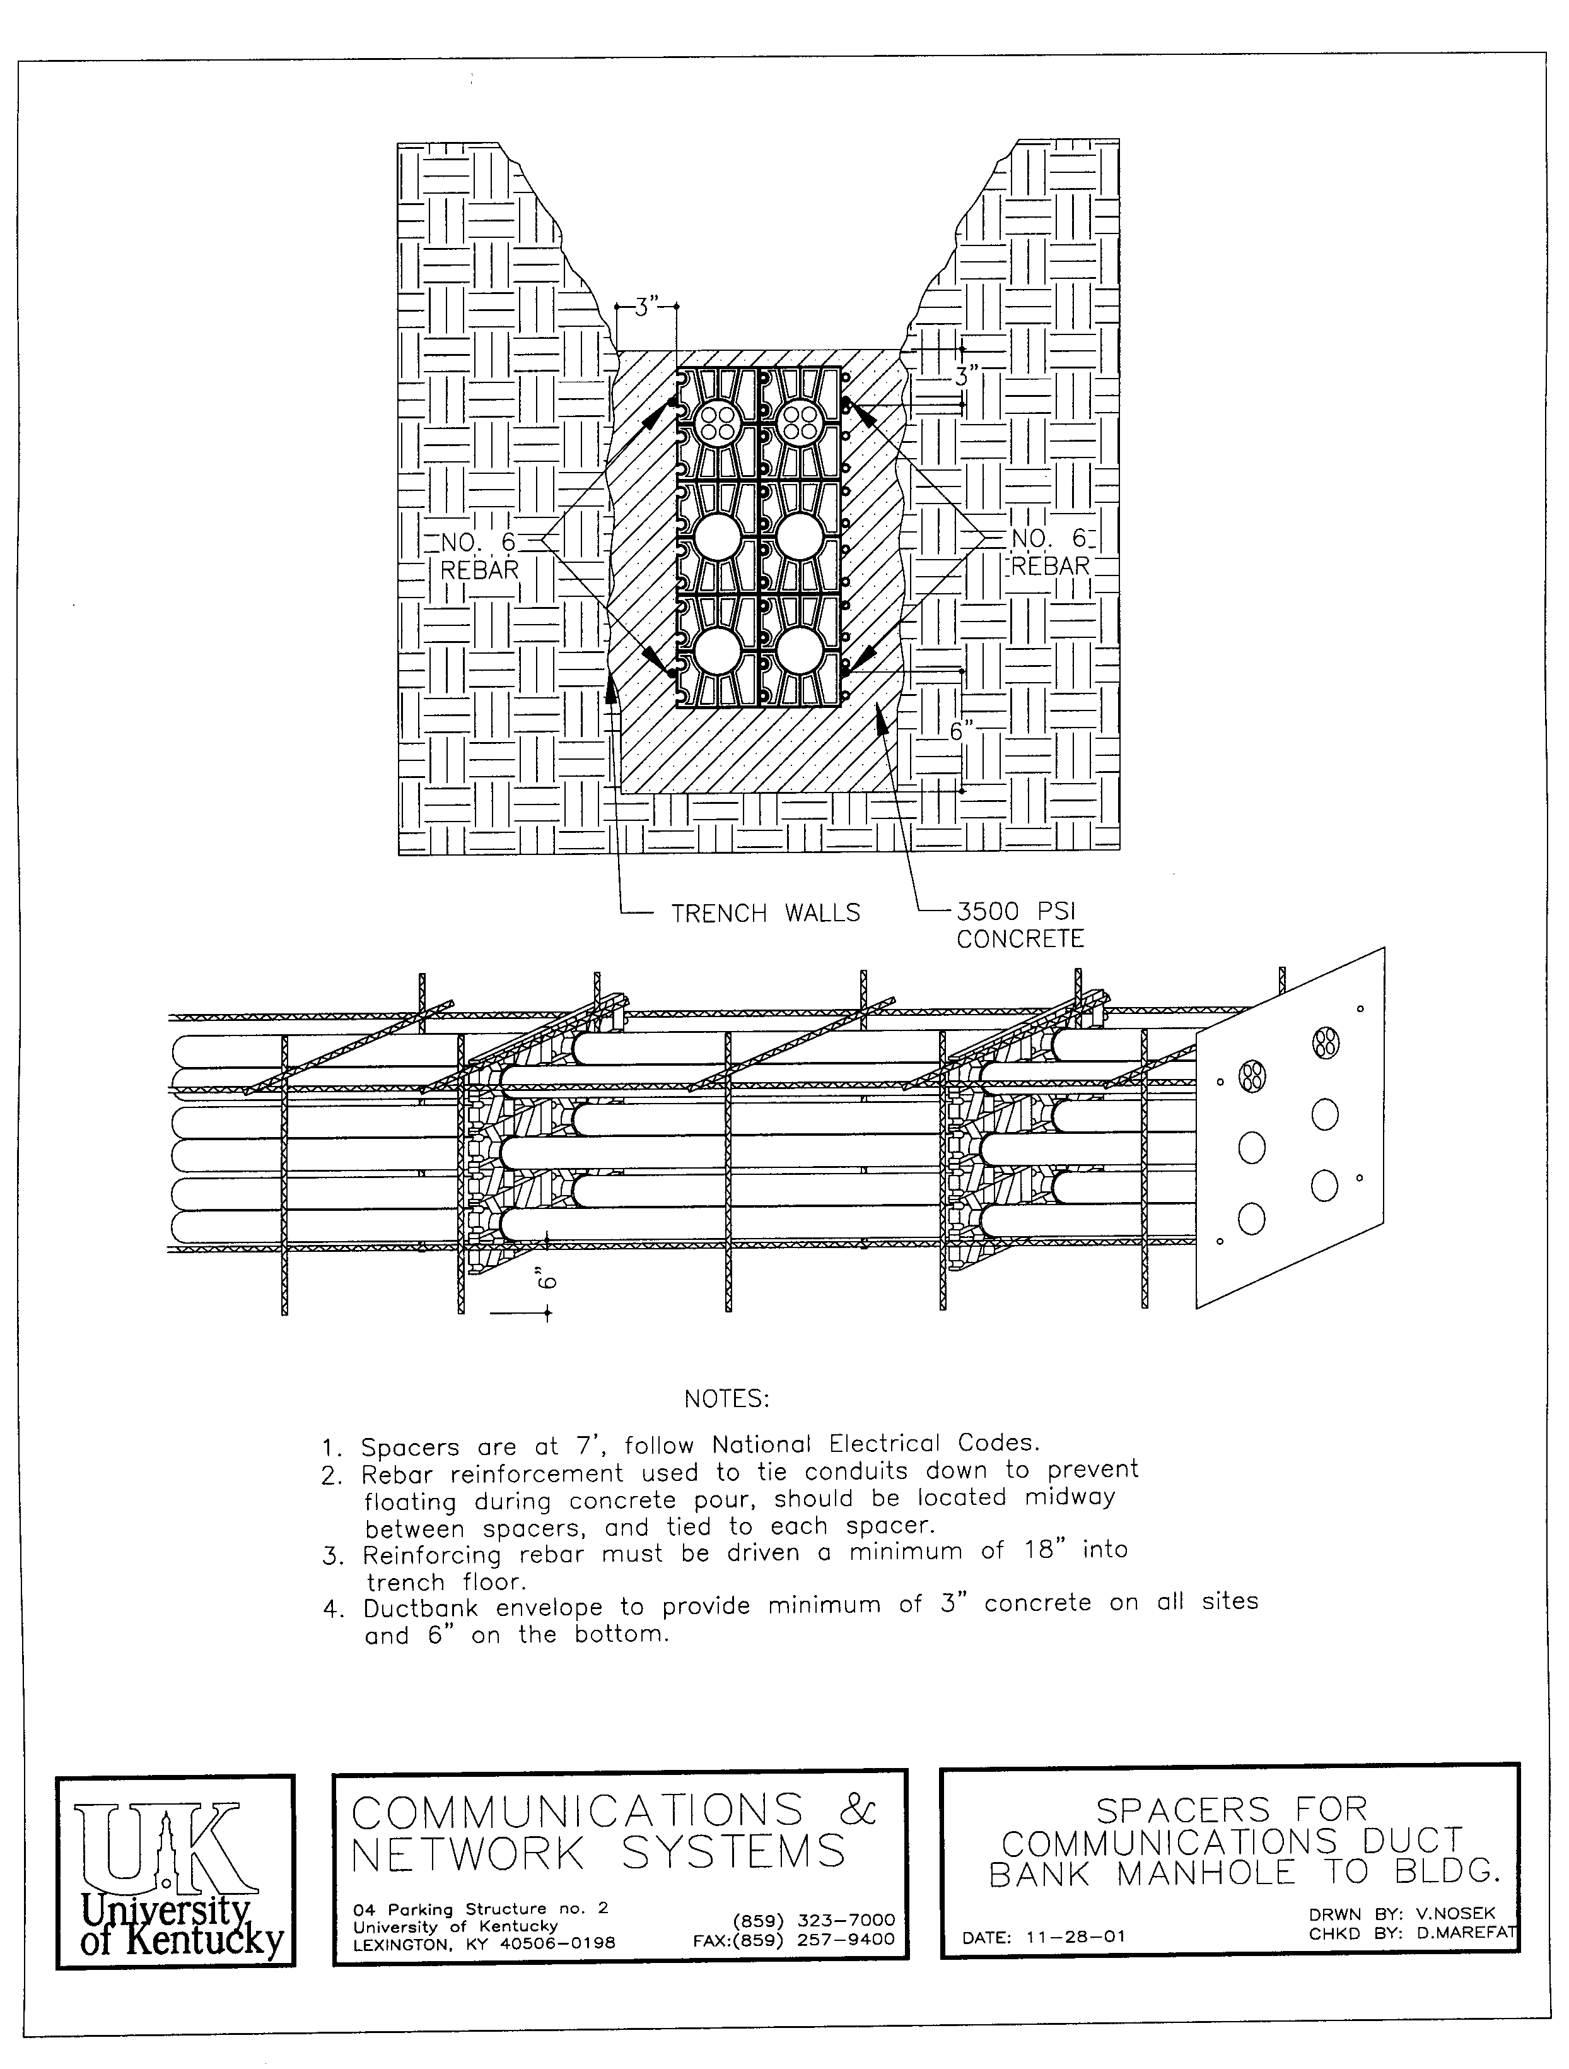

FIGURE 2 – Ductbank Detail
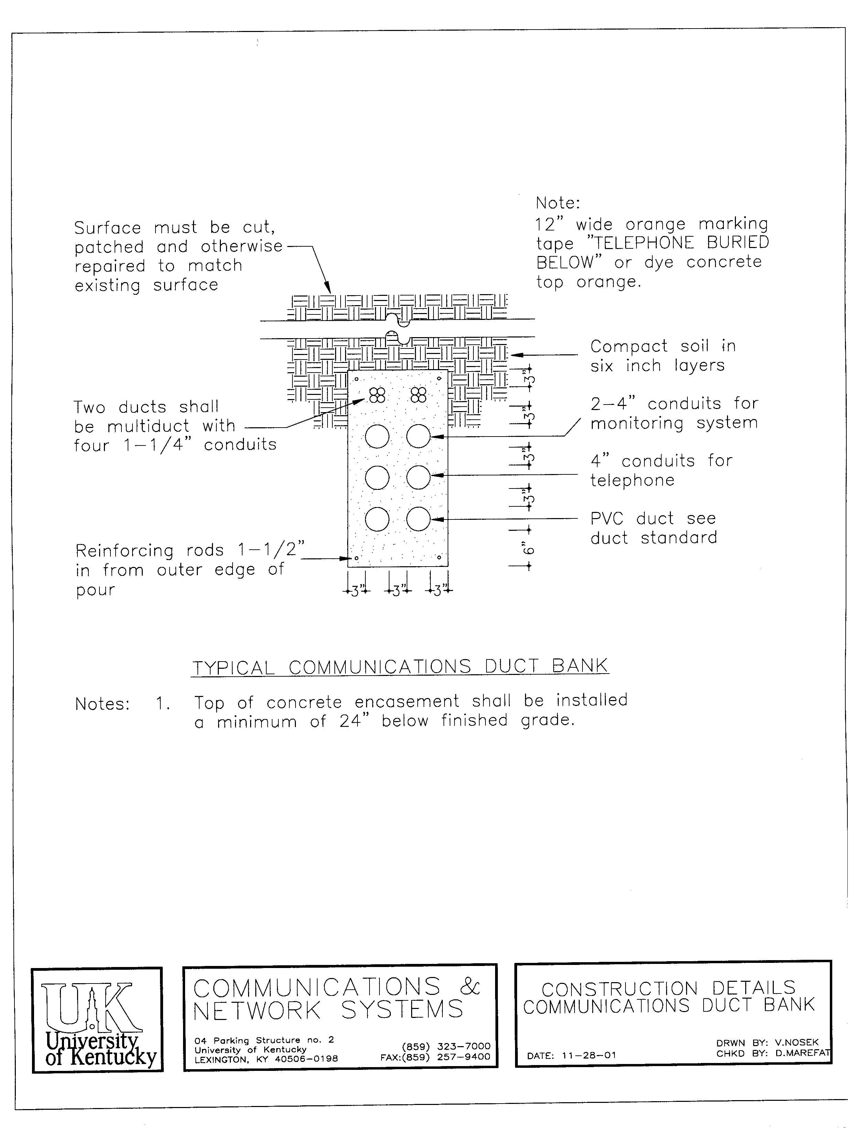

MANHOLES

General
Minimum manhole interior dimensions shall be 6' wide x 8’ long x 7’ high (See Figures 3 & 4).
The maximum depth of all manholes shall be ten (10) feet from the bottom unless otherwise approved by CNS Design and Engineering.

All manholes shall be cast in place concrete.

All manholes shall be equipped with a Neenah Foundry cat. No. R-1640-B1 frame and cover. The manhole cover opening shall be a minimum of 27 inches in diameter and shall be cast with the word "TELEPHONE" and the manhole number assigned by CNS Design and Engineering. Manhole covers are to have recessed handles that pull out when needed for removal or indented pick points. Double sealed manhole covers with handles shall be used in areas with the potential of vandalism and/or flooding. Refer to Appendix A for approved manhole cover manufacturer.

Telecommunications manholes shall not be adjacent to nor share any walls with electrical manholes.

The maximum distance between manholes connected in any one run is 400 feet. The quantity of 4” conduits and quad Tel-Ducts between manholes will be determined by CNS Design and Engineering.

Interiors
All materials used in a manhole shall be resistant to corrosion. All steel shall be galvanized or zinc coated.

Manhole racking equipment and cable supports are mandatory for all manholes. All racks in manholes shall be galvanized or zinc coated. Manholes shall have pulling rings cast into the wall opposite to each conduit entrance.

All manholes shall have cast-iron steps for climbing in and out.

Manholes shall be equipped with sump pump, electrical outlet and light. Ejected water from the manhole must discharge into a storm sewer, or at a distance with positive drainage, away from the manhole or conduit bank. A drain pipe or sleeve penetration of a two (2) inch minimum diameter shall be provided near the top of the manhole for drainage.

All conduits entering a manhole will be sealed from the outside of the manhole prior to backfilling. All conduits must be extended into the manhole 4 inches and be clearly tagged.
Any joints in manholes are required to be watertight.

Cables and Labeling
All cables entering a manhole must loop around the manhole to allow for expansion of the cable. Looped cable shall be kept a minimum of six (6) inches above the floor of the manhole.
All cables will be labeled at both ends using aluminum or stainless steel tags with the following information.
- The owner of the cable
- Cable number
- Cable type
- Pairs utilitized
- Termination point.
Example: CNS, Cable 05, SS 100, 101-200, PKS #2

FIGURE 3 - Communications Manhole Cross Section

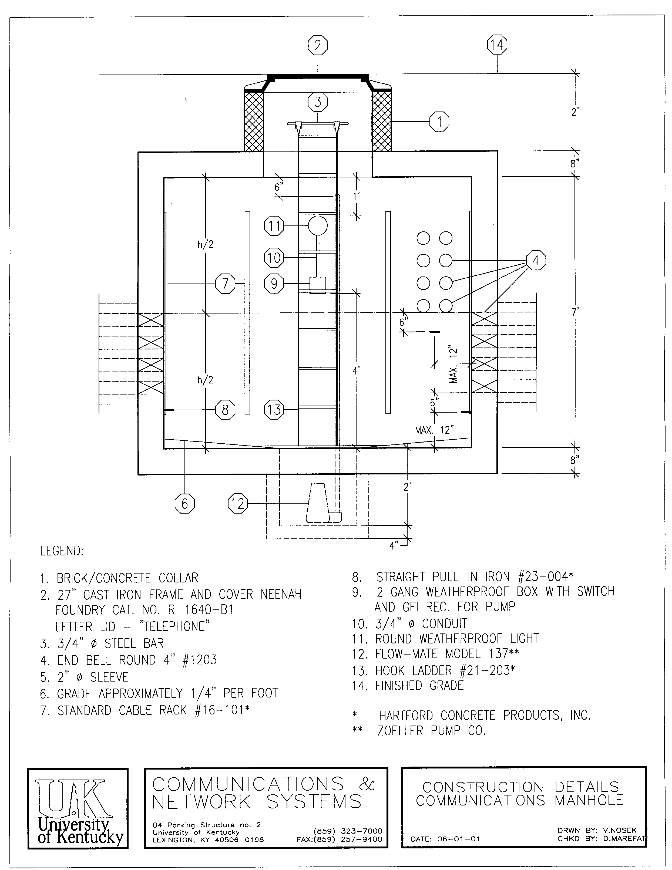

FIGURE 4 - Construction Details – Communications Manhole
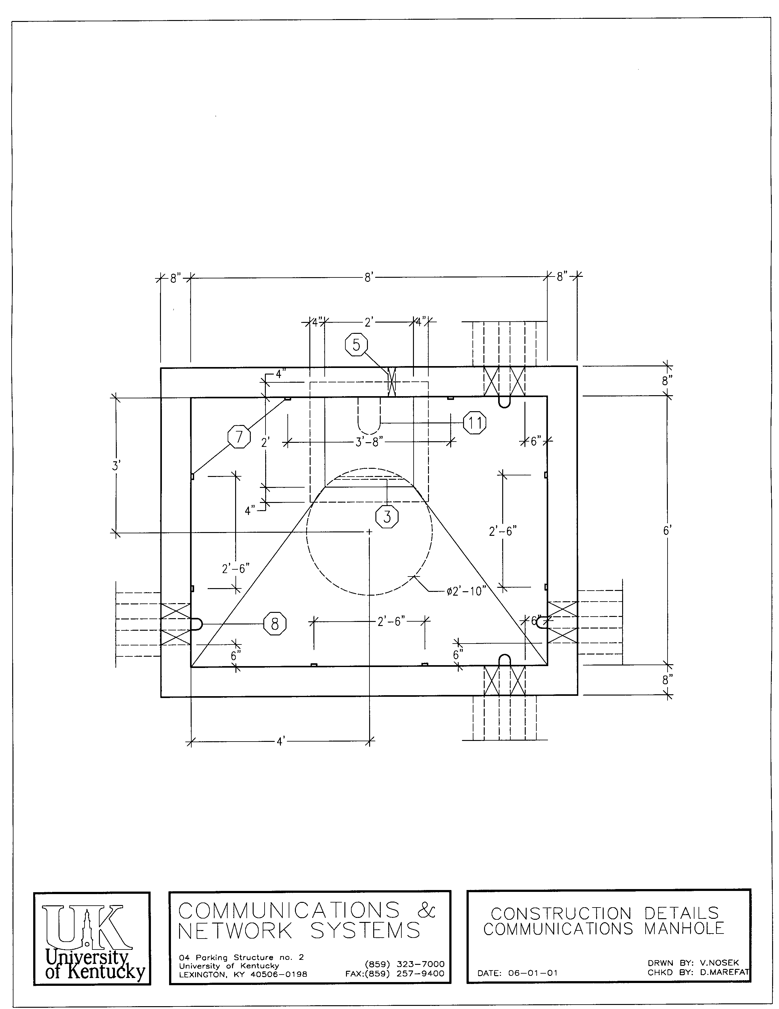

7.0 TelECOMMUNICATIONS ROOMS

Definition

Telecommunications rooms are special-purpose rooms that house telecommunications equipment. These rooms have stringent requirements due to the nature, size, expense and complexity of the equipment housed in them. Telecommunications room sizes vary according to the size of the building, number of floors, tenancy characteristics and telecommunications services required. Consideration to the future needs of the facility and the end users is a necessity.

Requirements

General Requirements
All work shall comply with the National Electrical Code, Kentucky Building Codes, and the University of Kentucky Communications and Network Systems Standards. The guidelines developed by ANSI/TIA/EIA and BICSI (Building Industry Service Consultants International) shall be followed in both design and construction of Telecommunications rooms.

To facilitate the proper installation, routing and placement of cables, premise equipment and terminal fields, Telecommunication rooms shall be located on each floor in the middle of the building, instead of either end, and stacked one above the other, unless otherwise instructed by CNS Design and Engineering. Telecommunications rooms will be located to assure compliance with TIA/EIA distance limitations. Architects must pay extra attention to room locations to adhere to distance limitations. The total horizontal distance of the cable path from the outlet to the Telecommunications room shall not exceed 295 feet, including termination loss and slack.

All Telecommunications rooms will be equipped with a smoke detector connected to the building fire alarm panel. An approved fire extinguisher must be provided just inside the door of each room. Sprinkler heads installed in Telecommunications rooms shall be high temperature heads covered with a wire cage.

Electrical distribution panels are strictly prohibited in any new Telecommunications rooms.

DOORS AND LOCKS - Doorways to Telecommunications rooms shall be designed with minimum measurements of 3’ x 6’ 8” and shall open outward into the corridor. The Office of Fire and Accident Prevention may approve limited exceptions. All Telecommunications room doors are to be keyed alike. Locksets shall be self-locking storeroom function. CNS will supply the key number to be used. The Director of CNS Design & Engineering will approve in writing all keys issued.

FLOORS - Floors shall be VCT tile or sealed concrete. Carpet is prohibited.

SLEEVES - Install steel sleeves between stacked telecommunications rooms. Sleeves shall be 4” AFF and extend to maximum of 10’ AFF of the floor below. Each end will have a bushing. All sleeves will be bonded to the ground busbar in the Telecommunications room.
A minimum of two (2) sleeves on three (3) walls is required. Coordinate with CNS Engineering for verification of quantitiy and placement in the TR. All sleeves must be fire caulked and sealed. Initial fire caulking is the responsibility of the contractor installing the sleeves.

CEILINGS - Telecommunications rooms will not have a suspended ceiling. The recommended minimum ceiling height is 8’ 6”. Preferred ceiling height is 9' 6" permitting cable tray mounting at 8' 4" with adequate tray top access.

General Requirements, continued

CABLE TRAY – 4” deep Cable tray will loop the entire perimeter inside a Telecommunications room at no less than 8’ AFF. Maintain a 4” clearance from each wall. Support with trapeze made up of rebar and unistrut. See sections later in this document regarding additional cable tray requirements.
Universal 12” cable tray will be installed at the top of the communications racks spanning the width of the room. Additional sections may be added to the voice backbone wall field. Radius drop outs will be installed on all cable trays where cables exit the tray to a lower elevation.

DRAINAGE - Telecommunications rooms will not have floor drains in order to avoid the threat of back flooding. Telecommunication rooms shall not be located in any area which may be threatened by flooding. Rooms cannot be located in basements susceptible to flooding. CNS Design and Engineering must approve any exceptions.

WALLS - Fire treated plywood, 3/4 inch thick, must be mechanically fastened to all walls of each Telecommunications room. The plywood will be painted with two (2) coats of neutral color fire resistant paint. The fire treated plywood will begin at 4” AFF and end at 8’ 4” AFF. The room walls will be finished with drywall (completely taped, sanded, and painted) or concrete block (painted) prior to mounting the plywood.

Telecommunications Room Sizing
Entrance Facilities - Telecommunications services entering a building shall be extended to the Telecommunications Entrance Facility. The minimum area allocation is 100 square feet (10’ x 10’) or 150 square feet (10’ x 15’) when the room is to be shared with computers, telephone switches, PBX or large key systems. Other exceptions may apply. CNS Design and Engineering shall be contacted for final footage approval.

Floor Serving Rooms - One (1) or more Telecommunications Rooms (TR) will be required on each floor. The minimum dimensions for a floor serving TR is 8’ x 6’. Telecommunications rooms serving floors of 10,000 square feet or larger may be sized based on 8 square feet for each 1000 square feet of net floor space. CNS Design and Engineering will evaluate actual sizing during the design phase of the building.

Shallow Closets - In existing or retrofit buildings, minimum TR sizes may not be possible. If the use of a shallow closet is approved by CNS Design and Engineering, the minimum dimensions shall be 6’ deep by 8’6” wide by 8’ high. The door to the room shall be a minimum of 36 inches wide. If a double door is used, the center post shall be eliminated. Due to space limitations and safety concerns, no equipment other than punch down blocks and wall-mounted equipment shall be housed in this closet. Refer to NFPA 80: A shallow communications closet is acceptable only for areas that are less than 1000 square feet. Contact CNS Design and Engineering to obtain permission, authorization and evaluation of space.

Environmental Control
All Telecommunications rooms shall be environmentally controlled to maintain a room temperature range of 65 to 75 degrees Fahrenheit with a maximum relative humidity level of 50 percent. Telecommunications rooms shall be conditioned with a fresh air exchange of four (4) air changes per hour. In that the University Systems does not generate chilled water during the winter, room cooling ability must be provided to remove a minimum of 7000 BTU per hour 24 hours a day, 7 days a week.

No plumbing, HVAC, or electrical conduit shall pass through, or be directly above, the Telecommunications room. In renovation projects where new Telecommunications rooms are established, all overhead utilities will be relocated out of the room.

Electrical Requirements
Under no circumstances shall electrical or any other utility panel be located in any new Telecommunications room. All walls are to be used for telephone blocks and terminations.

Lighting shall be open 2' x 4' fluorescent lights and provide a minimum illumination of 100 FC per square foot. The lights shall be connected to an emergency generator when available.

Multiple fourplex AC outlets must be provided to power telephone key systems, computer interfaces and other telecommunications equipment. A minimum of one (1) fourplex outlet per wall is required. Each fourplex outlet shall be connected to a dedicated 20 Amp, 110 V, 60 Hz circuit breaker. One (1) fourplex outlets will be installed at a height of 7’ AFF. CNS Engineering will determine the location. Some UPS equipment will require a 30 Amp circuit with a twist lock receptacle. CNS Design and Engineering will determine the need and the placement of this outlet. All circuits must be tied to an emergency generator when available. Outlets must be flush when cut through plywood.

All Telecommunications room circuits are to be labeled and identified in breaker boxes to avoid being turned off in error.

All Telecommunications rooms shall have a grounding bar, which measures 12” long by 2” wide by ¼" thick with pre-drilled ¼” holes. The ground bar shall be connected to the main building ground using #2 or greater AWG copper wire with a maximum resistance of 0.5 ohms or less. NEC requirements shall be followed.

All cable tray within the TR shall be grounded to the main building grounding system with a wire not smaller than #2 AWG copper. Ground wire and clamps will be installed on the exterior of the cable tray.

Termination Hardware
The design for the placements of racks, rack hardware, and wall fields within the TR will be approved by the CNS Design and Engineering.

Equipment Racks
Heavy duty aluminum 7’ floor mount racks with cable management channels on both sides and mounting rails for 19” equipment are the standard for new buildings. Rack types for existing or retrofit buildings shall be evaluated and approved by CNS Design and Engineering prior to installation. All racks will be properly anchored and grounded. Cable tray will be installed from the wall to the top of the racks for routing cables. Radius dropouts will be used wherever cables leave the tray. See Appendix A for approved manufacturers.

Rack Mounted Hardware
Rack elevation drawings showing termination hardware placement are required for approval prior to installation. Optical fiber distribution shelves will be installed in the top positions of the rack. For TRs with multiple racks, blank panels will be installed in the top positions to reserve the equivalent of seven (7) rack mount spaces in all racks that do not require fiber closures. Patch panels will be installed with horizontal wire management panels above, below and in between each panel. See Appendix A for approved manufacturers.

Wall Mounted Hardware
Wall mounted voice blocks will be properly secured to the plywood backboard. Location of the blocks within the TR will be approved by CNS Design and Engineering. D rings will be installed for wire management on the backboard. Standard 50 pair 66 blocks or 110 blocks will be used for voice backbone cable terminations not requiring protection. Wall mounted protections blocks must be approved by CNS (see grounding).

Labeling
All racks, distribution frames, connecting blocks, patch panels, optical fiber panels, and grounding busbars must be properly labeled. Refer to ANSI/TIA/EIA and BICSI TDMM for recommended industry standards.

FIGURE 5 – Telecommunications Room Layout
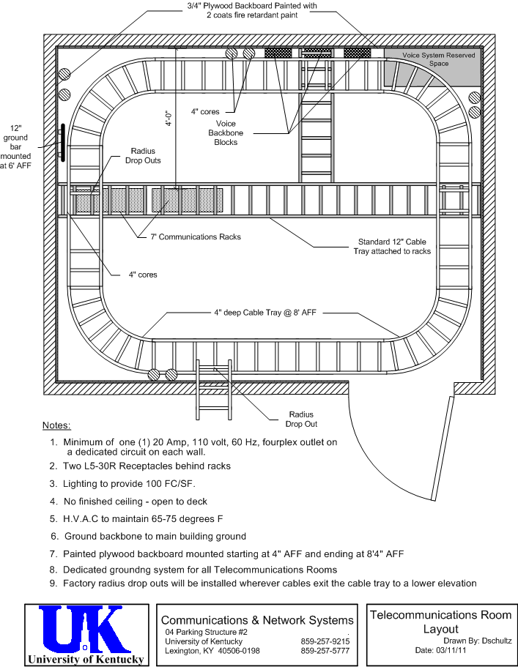
../../AppData/Local/Microsoft/Windows/Temporary Internet Files/Content.Outlook/UK Symbol.htm

FIGURE 6 – Rack Elevation

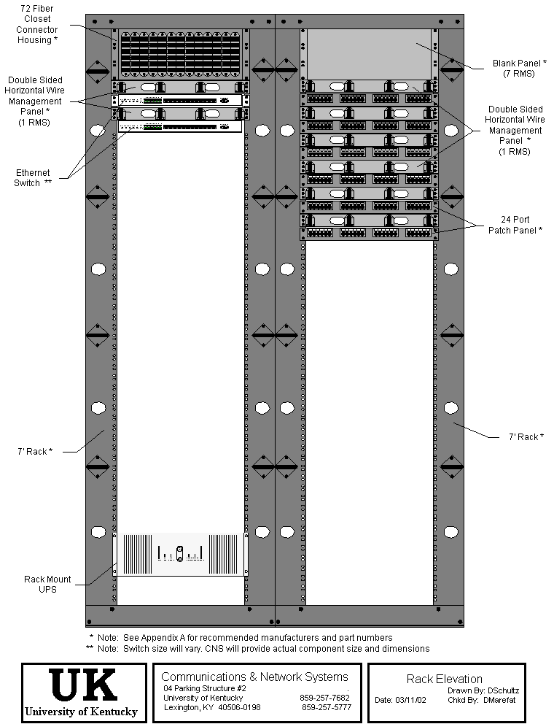

8.0 Optical FIBER TECHNOLOGY

General

Every effort was made to ensure that the information in this document was complete and accurate at the time of printing. However, technology is ever changing, becoming more efficient and effective and is subject to change. All optical fiber planning, installation and specifications shall be approved in advance by CNS Design and Engineering.

All cable that is to be connected or disconnected from the campus telecommunications network; telephone, data, video, to include Local Area Network, Wide Area Network, Cable Television, and fiber optics, shall be done by CNS. The cable shall be an accepted product of the United States Department of Agriculture Rural Electrification Administration as meeting the requirements of REA-PR-90. See Appendix A for approved manufacturer.

Minimum Fiber Qualities

For exact specifications contact CNS Design and Engineering.

All fibers in the cable must be usable fibers and meet required specifications. CNS will not accept cables that provide spare fibers. Manufacturers initial fiber test results will be attached to each reel at time of delivery.

All optical fibers shall be sufficiently free of surface imperfections and inclusions to meet the optical, mechanical and environmental requirements of this specification.

Each optical fiber shall consist of a doped silica core surrounded by a concentric silica cladding. The fiber shall be a matched clad design.

The multi-mode fiber utilized in the cable specified shall meet EIA/TIA 492A-1989. The single mode fiber utilized in the cable specified shall conform to the specifications.

The coating shall be a dual layered, UV cured acrylate applied by the fiber manufacture. The coating shall be mechanically or chemically strippable without damaging the fiber.

Minimum Requirements OSP Fiber Optic Cable

All OSP inter-building backbone optical fiber cable will be a hybrid Single Mode/Multi Mode cable. Fiber sizing will be determined by CNS Design and Engineering.

Optical fibers shall be placed inside a loose buffer tube.

Each buffer tube shall contain up to 12 fibers.

The fibers shall not adhere to the inside of the buffer tube. Each fiber shall be distinguishable from others by means of color-coding, EIA/TIA-598.

Buffer tubes containing fibers shall also be color-coded with distinct and recognizable colors according to EIA/TIA-598. The central anti-bending member shall consist of a glass reinforced plastic rod. The purpose of the central member is to prevent buckling of the cable.

Each buffer tube shall be filled with a non-hygroscope, non-nutritive to fungus, electrically non-conductive, homogenous gel. The gel shall be free from dirt and foreign matter. The gel shall be readily removable with conventional non-toxic solvents.

Buffer tubes shall be stranded around the central member using the reverse oscillation, or "SZ", stranding process.

The cable core interstices shall be filled with a water-blocking compound that is a non- hygroscope, non-nutritive to fungus, electrically non-conductive, homogenous gel. The gel shall be free from dirt and foreign matter. The gel shall be readily removable with conventional non-toxic solvents.

Binders shall be applied with sufficient tension to secure the buffer tubes to the central member without crushing the buffer tubes. The binders shall be non-hygroscope, non-wicking or rendered so by the flooding compound, and dielectric with low shrinkage.

The jacket or sheath shall be free of holes, splits and blisters.

The cable jacket shall contain no metal elements and shall be of a consistent thickness. The jacket or sheath shall be marked with the manufacturers name, the words "Optical Cable", year of manufacture, and sequential meter marks. The markings shall be repeated every one-meter. The actual length of the cable shall be within 0/+1% of the length marking. The marking shall be in a contrasting color to the cable jacket. The height of the marking shall be approximately 2.5 mm.

Fiber Physical Performance

The optical fiber cable shall withstand water penetration, when tested, with a one meter static head or equivalent continuous pressure applied at one end of a one meter length of filled cable for one hour. No water shall leak through the open cable end. Testing shall be done in accordance with FOTP-82, "Fluid Penetration Test for Filled Fiber Optic Cable."

The cable shall withstand a tensile load of 2700 N (600 lbs.) without exhibiting an average increase in attenuation of greater than 0.20 dB (multi mode) and 0.10 dB (single mode). The test shall be conducted in accordance with FOTP-33, "Fiber Optic Cable Tensile Loading and Bending Test," using a maximum mandrel and sheave diameter of 560 mm. The load shall be applied for one hour in Test Condition II of the FOTP.

Optical Fiber Cable Installation

Outside Plant (Infrastructure Cables)
All new ductbanks shall include at least two (2) conduits sleeved for fiber cable or use Quad Tele-Duct. Innerduct will be used only on pre-existing facilities.

All 250-micron fiber should be buffered up to 900 micron (in loose tube configuration), by means of loose tube fan-out kit.

When installing fiber optic cable in ductwork and manholes between buildings, there shall be a minimum of two (2) complete loops in each manhole. It shall be pulled in a protective liner inside the manhole to prevent damage to the cable. This liner could be extended and will vary due to circumstances. No splicing is allowed in fiber cables between buildings.

All fiber optic cables shall be terminated with an approved connector and properly connected to the distribution panel utilizing a cable end kit for each cable and an end kit for each tube. In that
Outside Plant (Infrastructure Cables) continued
connector designs are changing as new designs evolve connector types will be specified by CNS Design & Engineering. Allow 25 inches of slack from the end kit to the connector when in the same fiber closure, 47 inches if you pass into a second fiber closure.

Inside Plant (Riser Cables)
Riser rated Optical Fiber cable installed in conduit shall be pulled in a protective liner, minimum 1 1/4-inch inside diameter. When placed in a cable tray or on a runway where there is the possibility of someone standing, walking or sitting on the cable, it shall be placed inside a protective liner. When a floor trench is utilized (Walker type or equivalent) one chamber will be used exclusively for the fiber cable.

All cable placed along runways, relay racks and distribution shelves shall not exceed the manufacturers bend radius requirements for that particular type cable. When cable is secured by strap or other fasteners they shall not be pulled so tight at any point that the cable cladding is crushed flat or indented. Cable must move back and forth within the strap or fastener.

General
Jumper or patch cords are to be used to connect different fibers together for continuation of service. Do not wrap a jumper completely around a routing guide or other type bracket. When using routing guides on a relay rack always use the rear portion of the guides to hold vertical jumper runs and the front portion of the guides to hold horizontal jumpers. Always use the front routing guide to enter or leave housing.

There should be a minimum of 30-ft. slack left in a TR, mounted in a circular configuration on fire rated plywood (3/4 in.). This is necessary in the event of a fiber break.

All fiber strands shall be terminated in accordance with the industry standard color codes.

Label all fiber cable and all fiber strands at termination locations. CNS will provide fiber cable nomenclature.

Test all strands using an optical time domain reflectometer (OTDR) and optical loss test sets (OLTS). Provide test results of each fiber strand to CNS Project Manager within 10 days of completing terminations..

9.0 Inside Plant

General
All communications wiring shall be designed or approved by CNS Design & Engineering Group. User needs shall dictate the cable type and level.

All cabling will be installed according to NFPA 70: National Electric Code. Specific requirements for pathway types which include cable tray, enclosed wireway, conduit, or individual support systems will be determined by the building environment, accessibility, and approved by the appropriate party designated by University Enterprise CIO.

All cables will be 100 percent terminated.

To facilitate future cable installations, a new pull string, tied off at both ends, shall be installed in all pathways simultaneously with the pulling in of cable.

Backbone Cabling

Cable
All optical fiber, copper and coaxial backbone cable manufacturers and sizes will be approved by CNS prior to installation. A 50 percent growth factor shall be built in and provided for in all backbone cable unless otherwise specified. Consequently, any cable work that pertains to telecommunications must be designed and/or approved by CNS Design & Engineering.

See Appendix A for a listing of approved manufacturers. Alternates must be pre-approved by CNS Design & Engineering.

Termination
All copper pairs and fiber strands in backbone cables shall be 100% terminated unless otherwise directed by CNS Design and Engineering. Terminated fiber strands will be installed in rack mounted optical fiber distribution shelves. Multi-pair copper backbone cables will be terminated onto wall mounted 66 blocks or 110 blocks.

Labeling
Both ends of all backbone cable shall be labeled. Labels will be self laminating and machine generated, absolutely no hand written labels will be accepted. The label shall contain the following information:
- The Origination (TR it is feeding from).
- The Destination (TR it is feeding).
- Number of pairs or fibers
CNS will approve all labeling schematics prior to installation.

Horizontal Cabling

Cable
All voice and data station wiring shall be continuous (no splices) from the nearest TR cross connect to the communication outlet.

The department's present and future requirements will determine the needs of multiple jack outlets. Final approval for the layout of jack outlets shall rest with CNS. During the programming stage, information will be provided to the consultant for inclusion in the project.

The following cable types are utilized for horizontal cabling. See Appendix A for a listing of approved manufacturers

- Data and Voice – 4 pair 100Ω, balanced twisted pair cabling, Category 6 or higher cable.
- Fiber - One pair DIB cable shall be used as a minimum.

Note: Category 3 cables are not allowed in horizontal cabling.

Termination
All horizontal cabling shall be 100% terminated.

Data and voice horizontal cables will be terminated onto eight (8) position modular outlets at the workstation, and onto rack mounted patch panels in the TR.

The total wire path length from the outlet to the Telecommunications room must not exceed 295 feet in any case. This is important to meet Ethernet requirements of IEEE 802.3.

Labeling
All labels shall be machine generated (no hand written labels). All horizontal cables shall be labeled at both ends with self-laminating labels. The cable, workstation faceplate, panel ports and block positions shall be labeled with the room number, location in room, outlet type & # (data D1, D2 or voice V1, V V2). In rooms with multiple outlets, label clockwise as you enter the room: 1, 2, 3 e.g. a data port at the first drop location to the left of room 216 door would be - 216-1 D1). When terminating workstation cables in the TR, organize and label the cables in numeric room number order at the patch panel.

All modular outlets shall be identified as voice or data using manufacturer icons.

When a contractor provides the wiring, an "As-Built" drawing with all outlets identified must be provided.

Communications outlets
The University of Kentucky CNS department has defined a standard communications outlet which consists of two (2) 4 pair 100Ω Category 6 or higher cables. The cables will be green in color and be terminated for data connections. Exceptions to this will be building and user specific and identified in the design stage.

Locations and Quantities
Unless otherwise specified, the following number of outlets shall be installed in the following quantities, depending on the function for that particular office/room.

- Faculty/Administrative Offices: Each office shall have two (2) communication outlets per designated occupant.

- Clerical/Staff Offices: One (1) communications outlet at the location of each desk and one (1) additional outlet for a facsimile or printer. Each additional staff member in the same area will require additional outlets.

- Conference Rooms: A minimum of four (4) communication outlets per room. One (1) outlet shall be located on each wall. Rooms with more than 500 square feet shall have additional outlets equally spaced on each wall locations to be approved by CNS Engineering.

- Laboratories/Graduate Student Offices: Two (2) communications outlets for every occupant. Additional outlet requirements will be determined based on size in the design phase of the project.

- Classrooms/Lecture Halls/Auditoriums: One (1) to four (4) communication outlets depending on room and student occupancy size. See drawing.

Number of Outlets (Student Occupancy) TV Outlets *
4 1 – 16 2
6 17 – 32 4
8 33 - Over 6

The recommended location priority for the outlets would be:
1) Chalkboard and near ceiling,
2) Inside walls with proper spacing,
3) Projection booth/rear wall,
4) Remaining sides.

- Residence Halls: One (1) communication outlet per occupant of each room. The location will be determined during design stages of the project.

- Patient Care Rooms: One (1) communication outlet per occupant.

- Storage Areas: One (1) communication outlet per room. Two (2) outlets per room over 500 square feet with one (1) additional outlet for each additional 200 square feet.

- Janitor Closets: Consult UKPPD. Some closets require communications outlets for telephones, computers or time reporting devices.

Outlet Installation
Standard communications outlets are installed with four (4) port, single gang faceplates (see Appendix A). All unused ports will be covered with a blank insert.

Outlet Box –
- Category 6 cable - All faceplates will be mounted with a 4 11/16” x 4 11/16” x 2 1/8” outlet box, Steel City part number 72171-1 and a single gang plaster ring 72-C-13 for Categor 6 cable. When mounting the outlet box in a steel studded wall, use a back brace.
- Category 6A cable – all faceplates will be mounted with a 5” x 5” x 2 7/8” box with a single or double gang plaster ring. Ring size to be determined on individual basis.

Outlets are to be mounted at standard industry heights and positions, unless otherwise specified..
Standard mounting height of communication outlets:
- Desk 18 inches, AFF.
- Wall phone 60 inches, AFF.
- ADA wall mounts 48 inches, AFF.
- Cable Television is normally installed at the height of TV mounting

Note: Electrical outlets shall be provided for TV and projection devices.

10.0 horizontal pathways

General
All work shall meet the specifications of NFPA 70: National Electrical Code, and follow the recommendations found in TIA and BICSI standards.

University Communications and Network System Division reserves the right to review all communications pathways. All pathways must be approved by the appropriate party designated by the University Enterprise CIO.

In-wall data outlets will have a minimum of one (1) 1” conduit stubbed out to the nearest accessible ceiling space or to the nearest primary horizontal pathway. Each will have the properly sized outlet box identified in the previous section. Any exceptions must be approved by the appropriate party designated by the University Enterprise CIO.

Cable Support Systems
The installation of support systems that utilize individual support hardware such as J-Hooks must be approved by the appropriate party designated by the University Enterprise CIO and installed properly following TIA and BICSI standards for spacing and attachment to building structure.

This type of support system will be used only in accessible ceiling areas. This system will not be installed above inaccessible ceiling (i.e. gypboard ceiling).

Supports will not be installed with wire. Attachment will be to building structure using proper means.

Attachment to ceiling support systems is not acceptable in any installation.

All supports will be installed with a maximum spacing of 48”. This distance may be reduced in high volumn pathways.

Only wide base support units may be used.

Individual cable support hardware will be sized properly to accommodate the current installation plus 50% growth.

Conduit
Minimum size of conduit serving one data outlet will be 1” ID.

Sizing of conduit for primary pathways will be determined by the quantity of cables plus 50% growth. Junction boxes will be sized per NEC.

No more than an equivalent of 270 degrees of bend, including offsets, are allowed in a conduit run between junction boxes or pull boxes.

Absolutely no “LB’s” are allowed in any communications conduit installation.

Per NEC, junction boxes are to be provided on any conduit run longer than 100 feet. An outlet box is not acceptable as a junction box.

Entrance to junction boxes or distribution panels shall be adjacent to the corners.

All EMT fittings shall be compression type. Setscrew fittings are NOT acceptable on conduit less than 2-1/2 inches in diameter.

No surface mounted conduit will be acceptable except in mechanical rooms or approved by CNS. All other applications requiring surface mounted outlet will utilize metal surface mounted raceway (no plastic raceway allowed).

PVC conduit and plastic molding are not acceptable except in caustic environments.
The numbers of bends will not exceed 270 degrees including offsets in any conduit.

Pull boxes must be installed after every 270 degrees of bend (including offsets) or 100 feet of the conduit run. Use only compression fittings at joints.

All conduit cast in the floor slab shall be a minimum of 1-1/4 inch galvanized steel with threaded fittings. All exceptions shall be determined during the design stage of the project and shall be subject to the approval of CNS Design and Engineering.

Conduit at Cable Trays and Wireways
Conduit ends at a cable tray will have plastic bushings and be wire bonded to the tray.

Conduit ends at a wireway will be mechanically fastened, have plastic bushings, and be wire bonded to the wireway.

Note: A mineralic strap is not acceptable as a means of grounding the conduit to the cable tray.

Conduit that terminates in the TR must have plastic bushings and be wire bonded to the ground busbar located in the room.

Conduit Capacity
All conduits will be sized to maintain the industry recommended 40% fill capacity. For sizing calculation purposes it shall be assumed that each communications outlet will require a minimum of four (4) 4-pair cables.

Sleeves and Risers
Sleeves shall be installed between stacked Telecommunications rooms. Telecommunications rooms that are not stacked will require the installation of six (6) riser conduits (4 inch minimum diameter) connecting all Telecommunications Rooms together. A pull string and appropriate junction pull boxes shall also be provided in each conduit run to facilitate future installation of cable(s).

All floor sleeves must protrude four (4) inches above finish floor and extend to maximum of 10’ AFF below the floor slab. Each end will have a bushing. All sleeves will be bonded to the ground busbar in the Telecommunications room.
Sleeves will be firstopped.
Coordinate with CNS Design and Engineering for the quantities and locations of the sleeves.

Cable Tray

All cable trays shall be designed to accommodate all communication cabling and must be approved by CNS Design & Engineering during the initial design phases of a project. The cable tray will not be used to support any other services such as conduits, junction boxes or ceiling support grid.

The cable tray shall be “ladder” style, have the minimum dimensions of 12 inches wide and 4 inches interior depth.
Rung spacing will be a maximum of 6” over the entire length of the cable tray.
Special attention must be given to elevation changes and corners to provide cable support. Only factory corners, T’s and radii are to be used (i.e. sweeping factory 90's for all turns).
Dropouts will be installed at all points where communications cables will exit the cable tray.

Contract documents shall show cross section of the communication wireway or cable tray. The drawing should allow a 12” clearance above the cable tray in reference to other utilities in the building. The drawing should also indicate a minimum of 24” along one the side of the tray to allow access from below the tray. Cable trays must be a minimum of six (6) inches above the ceiling and a minimum of eight (8) feet AFF. Cable trays will be the first utility above the ceiling.

Installation of other types of cables in the communications cable tray (security, alarm, fire safety, Building Automated Systems, etc.) must be approved by CNS Design & Engineering prior to the project start.

Cable tray will loop the inside perimeter of all Telecommunications rooms.

All cable tray is to be mounted using a trapeze method with allthread rods and unistrut. Fasten allthread to ceiling anchors, allowing no bends in allthread. Support the cable tray in this manner at every section-to-section junction and at five (5) foot to six (6) foot intervals (mid span) between joints. In no case shall the tray be closer than eighteen (18) inches from the structural ceiling, ducts or pipes, considering all other possible obstructions. A minimum of two (2) feet distance from lighting, especially fluorescent lighting, is required. Supports for cable tray that is less than 12 inches wide may be farther apart but must meet or exceed the manufacturer's installation requirements. A single support per section length is not acceptable.

Where cable trays penetrate walls provide for smooth sealed edges on all four sides of wall. This is necessary to properly firestop all edges.

CNS will not install any cable, or perform any work, until all installations are made to comply with these specifications.

Wireway

Wireway shall be designed to carry the weight and size of all cables required. The wireway will not be used to support any other services such as conduits, junction boxes or ceiling support grid.

Minimum wireway size shall be 6 inches x 6 inches.

All wireway will be mounted using a trapeze method with allthread rods and unistrut.

Do not bolt wire way directly to the wall. This method is not acceptable.

90 degree bends are to be made using two (2) 45-degree sections. All conduits are to be connected according to the manufacturer's specifications and must meet NEC. A 24” clearance is needed for pulling cable.

A pull string will be provided in all new wireways.

All wireway doors must be clear of obstructions.

The wireway is to be installed with the hinges on the bottom so that the door opens in a downward direction. Contractor will be responsible for closing all hinged sections at the end of the project.

Use only manufacturers original equipment latching devices.

All rough edges must be filed smooth.

No sheet metal screws will be allowed. Sections are to be joined using only flathead nuts and bolts with the bolted side protruding from the enclosure

Underfloor Duct System

This type of raceway is to be used in buildings where occupants move about often or when access is required on a demand basis. Various types are available. Care must be taken to design a system that will consider electrical and communications requirements. Adequate electricity must be available at all locations. With proper planning an adequate system can be installed. Any proposed system must be approved by CNS Design and Engineering prior to installation.

11.0 CATV & video

General

For additional detailed specifications regarding television cables, contact the Department of Instructional Telecommunications.

CATV & Video riser cables in multistory buildings shall be 75-ohm cable. As a rule the minimum acceptable riser cable is 500 coaxial cable. Obtain all cable design and sizes from CNS.

CATV & Video outlet cable shall be RG-6/U type quad shielded coaxial 75-ohm, Belden part number 1189A or equivalent.

Each TV outlet may provide video capabilities. Customer requirements will be conveyed to CNS.

Each outlet shall be home run to the nearest communications room.

Video/Projection Devices, Cabling and Outlets

CNS or Instructional Telecommunications shall provide the specifications and cable parts for projection devices and /or monitors.

Projection devices are either ceiling or table type mounts. In each case the conduit must be connected to the front of the classroom. See attached drawing.

There are many specialized systems being utilized at the university. Each will require their own specialized installation, for example MNET at the Medical Center.

12. PrOTECTION, GROUNDING, AND BONDING

Lightning Protection

General
Lightning protection of telecommunications facilities is essential. While federal and state standards must be adhered to, local conditions may require additional investigations and/or modifications to meet site, equipment, environmental or safety requirements.

NEC Articles 250 "Grounding" and 800 "Communications Circuits" cover general requirements for grounding, bonding and protecting electrical and communications circuits. NFPA 78 "Lightning Protection" addresses zone protection and other items that are beneficial.

All lightning and power failure protection for all cabling and wiring (including grounding) within the building and entrance facilities with protection from lightning and power failure via grounding and bonding will be accomplished under the construction contract.

Materials
Approved lightning protection devices are listed in Appendix A. Contact CNS Design and Engineering a determination of the most appropriate protection for the actual conditions.

Grounding

All related NEC codes shall be followed. Conduit will not be used as a ground for any system.

All grounding shall use single point schemes from the building main transformer, with a minimum of #2 AWG stranded copper conductor, which has been tested to a maximum of 0.5 ohms.

All shields shall be bonded to a common ground.

All riser cable must be shielded and properly grounded to the building ground.

Bonding

Bonding will be durable, strong and of low impedance to assure electrical continuity.

All conduits terminating to cable trays and wireways shall be mechanically fastened. If connected to a tray, it must be equipped with ground bushings and wire bonded to the tray.
The cable tray or wire way shall be grounded to the main building grounding system with a wire not smaller than #2 AWG copper.

A resistance of .001 ohm or less indicates a high-quality junction (BICSI).

13. INSPECTION AND TESTING

Inspection of Work

Inspection - General
CNS personnel shall have access to all construction sites at all times for purposes of installing and inspecting communications facilities and equipment.

To enable CNS personnel to inspect telecommunications facilities work, the contractor must:

- Provide a progress schedule with the installation of telephone raceways and spaces shown as a separate item.
- Immediately notify CNS in writing of any change in architectural or mechanical drawings and specifications affecting telecommunications.
- Provide proper access and facilities for inspections.
- Notify CNS when any work is ready for inspection.
- All underground work must be inspected and approved by CNS before the site is covered with dirt or concrete. Failure to have the work inspected shall result in uncovering the area at the contractor' expense.

The contractor shall provide a final checkout certification letter, and inspection reports to CNS on all telecommunications work. All systems installed by outside vendors will be required to provide a vendor inspection certificate and a vendor warranty with a binding commitment to a 15 year system performance warranty.

Testing

Testing - General
The contractor shall submit to CNS a detailed test procedure to be used for every project. All cables shall be tested for length, attenuation, impedance, ground shorts, continuity of communications conductors and shields.

All data cables will be tested for compliance to meet ANSI/TIA/EIA standards for the cable level installed. A copy of the final test results will be delivered to the CNS Project Engineer in both written and electronic form within 10 days of the project turnover date.

Upon completion, copies of as built drawings related to communications work and all test results shall be submitted to CNS for final approval and acceptance and made part of the document. The contractor shall guarantee 100% good pairs on all cables.

Communications will perform necessary testing before accepting a job. Failure during testing will result in re-pulling cables at the contractor's expense.

14. FIRE STOPPING

Provide fireproofing seals in accordance with the National Fire Protection Association (NFPA) and the National Electric Code (NEC.

Copies of certified U/L rated firestopping designs must be submitted to the CNS Engineering department for approval prior to installation of any materials.

Prepackaged intumescent materials are the preferred material for fireproofing. Do not use concrete for fire stopping on cable trays, wireways or conduit. Contractors who use this method will be required to replace all cables affected. Use materials intended and approved by codes and applicable authorities..

Observe the special provisions of contract documents that may require the firestopping of all penetrations required by the work covered under this document. In general, all locations within the Medical Center require firestopping of all penetrations.

Appendix A

Approved Manufacturers
Horizontal Cabling
Amp
General Cable Corp.

Horizontal Termination Hardware
Amp

Copper Backbone Cabling
General Cable Corp.
Superior Essex

Optical Fiber Cabling and Termination Hardware
Corning Cable Systems

Telecommunications Room Racks
Ortronics Might Mo

Cable Tray
Monosystems or equipvalent

Surface Raceway
Wiremold

Protection
AT&T
Marconi

Appendix B

Parts Listing

Horizontal Cabling
UTP 4/24 Category 6 PVC Cable (Green) Amp 1-219560-4
F/UTP 4/24 Category 6A PVC Cable (Green) Amp 4-1499389-2

Horizontal Termination Hardware
6 Port Faceplate Amp 557691-X
4 Port Faceplate Amp 558088-X
2 Port Faceplate Amp 557505-X
Cat 6 Modular Outlet Amp 1375055-X
Cat 6A XG Shielded Modular Jack Amp 1711342-2
Blank Inserts Amp 406339-X
Green Data Icons Amp 558198-3
Modular Furniture Faceplate (confirm opening size with furniture supplier)
Back Box for Data Outlet 4 11/16” x4 11/16” x2 1/8” Steel City 72171-1
Back Box for Cat 6A Outlets 5” x5”x2 7/8” Randl
24 Port Category 6 Patch Panel Amp 1375014-1
48 Port Cat 6A XG Angled Patch Panel Amp 1933322-2
Horizontal Cable Mngmnt Panels 1 RMS Panduit CMPH1
7" Blank Panel Kit Amp 556965-4
300 pr 110 Block Kit w/ legs Amp 569446-1
100 pr 110 Block Kit w/legs Amp 569440-1
Rack Mount 100 Pr 110 Block Amp 558635-1
X = coordinate color of faceplates, modular outlets, and blanks (all same color) with the end user and electrical faceplates (if not stainless steel).

Copper Backbone Cabling
300 pr UTP Riser Cable General Cable 2133373
200 pr UTP Riser Cable General Cable 2133323
100 pr UTP Riser Cable General Cable 2133144
25 pr UTP Riser Cable General Cable 2133033
900 pr OSP Armored 24 AWG General Cable 7525876
600 pr OSP Armored 24 AWG General Cable 7525868
300 pr OSP Armored 24 AWG General Cable 7525843
25 pr OSP Armored 24 AWG General Cable 7525785

Optical Fiber Cabling and Termination Hardware
24 Strand OFNR Fiber Cable SM Corning Cable Systems 024R81-33131-24
24 Strand OFNR Fiber Cable 62.5 MM Corning Cable Systems 024K81-33130-24
24 Strand OFNR Fiber Cable OM3 MM Corning Cable Systems 024S81-33180-24
12 Strand OFNR Fiber Cable SM Corning Cable Systems 012R81-33131-24
12 Strand OFNR Fiber Cable 62.5 MM Corning Cable Systems 012K81-33130-24
12 Strand OFNR Fiber Cable OM3 MM Corning Cable Systems 012S81-33180-24
6 Strand OFNR Cable MM Corning Cable Systems 006K81-31130-24

Outdoor Hybrid Fiber 48MM/48SM Corning Cable Systems 096XW4-141XXA20
Outdoor Hybrid Fiber 24MM/24SM Corning Cable Systems 048XW4-141XXA20
Outdoor Hybrid Fiber 12MM/12SM Corning Cable Systems 024XW4-141XXA20
Outdoor Hybrid Fiber 6MM/6SM Corning Cable Systems 012XWR-141XXA20
1” Innerduct (orange)
Fiber Connector Housing Pretium® Corning Cable Systems PCH-04U
Fiber Connector Housing Pretium® Corning Cable Systems PCH-02U
Fiber Connector Housing Pretium® Corning Cable Systems CCH-01U
Connector Housing Panels (12 SM fiber) Corning Cable Systems CCH-CP12-59
Connector Housing Panels (12 MM fiber) Corning Cable Systems CCH-CP12-91
Connector Housing Panel (12 LOMMF) Corning Cable Systems CCH-CP12-E6
Connector Housing Panels (6 SM fiber) Corning Cable Systems CCH-CP06-59
Connector Housing Panels (6 MM fiber) Corning Cable Systems CCH-CP06-91
Fiber SC Unicam Connector MM Corning Cable Systems 95-000-41
Fiber SC Connector SM Corning Cable Systems 95-200-41
Fiber SC Connector LOMMF Corning Cable Systems 95-050-41-X
Buffer Tube Fan Out Kit Corning Cable Systems

Telecommunications Room Racks
7' floor rack Ortronics Mighty Mo
12” Universal Cable Tray Zero PFT LR1012J

Cable Tray
4” deep Cable Tray (6” rung spacing) Monosystems
Horizontal Elbows, Vertical Risers, Ts,
Radius Drop Out
Connection components

Surface Raceway – Metal Only
Size to be determined Wiremold

Protection
Terminal Protection Block 100 pr Marconi R-355
Solid State Protector Modules Corning Cable Systems 6SPE-BT
Bldg Entrance Protector Panel (100 pr) Avaya 489BCB1-100
Solid State Protector Module Avaya 4C1S

Infrastructure Splice Components
Splice Closure Preformed 8000635
Splice Closure End Plate Kits Preformed 800081098
MS ² Splicing Module (Dry) 3M 4000-D/TR
MS ² Splicing Module (Filled) 3m 4000-D

