INFORMATION:

This standard is for filter clips on all air handling units (AHU) in Medical Center facilities.

HEPA Filters:

For HEPA filters, the filter rack needs to be a Camfil Magna-Frame II as pictured below or approved equal (equivalencies need to be approved during the submittal process and should not be installed until approved.). The frame needs to be supplied with the J-bolt type clip (also pictured below) for holding the HEPA filters in place.

Camfil Magna-Frame II
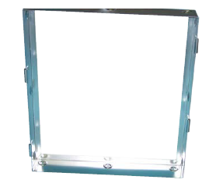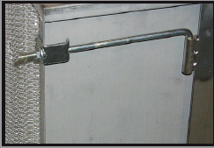

Pre-filters and Final filters

For pre-filters and final filters, the Camfil C78 series clip pictured below or approved equal (equivalencies need to be approved during the submittal process and should not be installed until approved.) is required. This clip comes in various lengths and the instlled clip must be sized to match the filter being held by the clip.

Camfil C78 series

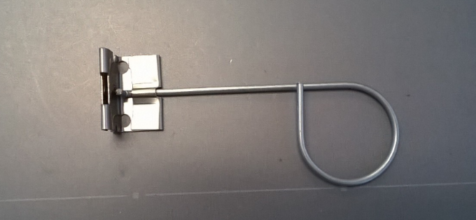

INSTALLATION:

The frames are to be connected together in such a manner that does not have any protrusions into the filter space which impacts the installation and removal of the filters.

