GENERAL
These numbering conventions have been developed and should be followed throughout University facilities for the purpose of standardizing room numbers.

For new buildings, these standards should be followed as closely as possible. In cases of renovations or additions to existing buildings, the building’s existing numbering system can be extended, or abandoned in order to use the following standards to renumber the entire building including the renovated and/or added space.

The intention is for each facility’s floor and room numbering scheme to be structured so that the numbers flow through the building in a consistent, comprehensible, and user-friendly pattern. The scheme should be clear to the users of the facility, not causing confusion for individuals attempting to locate spaces.

All constructed and renovated buildings owned by the University of Kentucky require room numbers for 1) emergency response, student, faculty, staff & visitor Wayfinding, 2) facility management & maintenance records & other operational purposes, 3) space and equipment inventory, and 4) federal, state, and financial (grants) reporting pursuant to the ‘Postsecondary Education Facilities Inventory and Classification Manual (FICM): 2006 Edition. Room numbering must be patterned and relatively consistent from building to building. If there is any deviation from these standards, it requires the approval of the Space and Facility Records Manager (or his/her designated representative) and input is required from the UK Space Inventory/SAP database programmers to be sure that what’s being proposed is feasible/possible from the university’s space inventory/PM database side.

Before the completion of Phase 2 – Design Development, the Consultant will provide key drawings (hard copy and digital) of the new/reconfigured space with the proposed room numbering system complying with the University’s Room Numbering Standards for review and approval by the University’s Space and Facility Records Manager. The approved key drawing, then determines the room numbers to be used for the room finish schedule, hardware schedule, equipment schedule, etc., for the Phase 3 – Construction Contract documents. And upon substantial completion of the facility, facilitates the inventorying of furnishings and equipment assigned to that room/space via a room ID bar code affixed to the middle hinge jamb of the door or other appropriate location.

Building Modifications: During renovation, all re-numbering of renovated rooms shall be consistent with the above standards and existing numbering in adjacent spaces. In cases where the existing room numbering system will not permit consistent application of the standards, consult with the Space and Facility Records Manager for further direction and approval of a proposed numbering plan. Partial renovations on a floor may not be justification for renumbering the entire floor as building controls, door keying, electrical panels, fire alarm panels, interior room signage, Space Inventory, Preventive Maintenance, Equipment Inventory etc. for the remaining spaces are impacted. Consult the Space and Facility Records Manager.

Room numbers can be up to 10 characters organized in the following sequence however there is no requirement that all characters be used on the drawings or room numbers affixed to the wall outside the space.

DEDICATED PREFIX’S

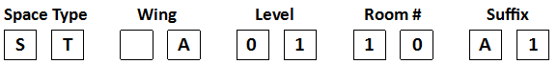

Listed below in Paragraphs 1.0 and 2.0 are dedicated Prefix’s that are recognized and reserved for use by the University’s Space Inventory database for the spaces listed.

1.0 SPACE TYPE
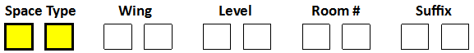
Prefixes listed first in a room ID typically interfere with sorting the rooms by floor number if they are listed later. The following Prefixes can only be used for the items noted in the table below otherwise the ‘Prefix’ is left blank or left available for use by the ‘Suffix’ if there are sub-rooms within suites. See Article 6.0 below for examples.

Space Type | Use
CH | Service Chutes (trash, laundry, etc.)
DT | Air Ducts
DW | Dumb Waiter
EL | Elevators
I | The letter ‘I” is not allowed in Prefixes/ Wings / Suffixes
LB | Lab Bench
LV | Parking Garage / Structure Levels
NR | Mechanical Interstitial spaces
O | The letter ‘O’ is not allowed in Prefixes/ Wings / Suffixes
PC | Pipe Chase
PH | Penthouse
RF | Roof
SH | Mechanical service shafts
ST | Stairs (through each floor in which they pass), whether interior or exterior, that are within the buildings drip line, or if covered within the covers drip line.
TL | Tunnels (36” or greater) Counts towards GSF of building
TN | Trench tunnels (less than 36” in height) Does not count towards GSF of building.
XA | Exterior areas, whether walled or not, that are within the buildings drip line, or if covered within the covers drip line. Counts towards GSF of building.
XB | Exterior stairs attached / adjacent to a building that provide access to said building, but are outside of the buildings drip line. Does not count towards GSF of building.
XC | Exterior ramps attached / adjacent to a building that provide access to said building, but are outside of the buildings drip line. Does not count towards GSF of building.
XD | Areaways for windows / doors that fall beneath exterior grade that are attached to a building, but are predominately outside of the buildings drip line. Does not count towards GSF of building.
XE | Exterior Courtyards / Plazas / Patio, whether wrapped entirely by a building or not, that are outside of a buildings drip line. Does not count towards GSF of building.
XF | Exterior Amphitheater attached/adjacent to a building, but outside of the buildings drip line. Does not count towards GSF of building.
XG | Load docks attached/adjacent to a building, but outside of the buildings drip line. Does not count towards GSF of building.
XH | Exterior Sculptures
XJ | Exterior equipment supporting a building (generator, condensing units, chillers, etc.)
ZZ | Undocumented Space

2.0 WINGS (for Floors Exceeding 99 Rooms)

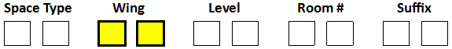

In new buildings where more than 99 numbered rooms exist on any floor, prefixes shall be used in accordance with the building layout (ie. wings A, B, C, D, E, etc.). (The letters ‘I’ and ‘O’ shall not be used for Wing designations.) If a wing or an addition of a multi-story building is assigned a prefix then the same prefix shall be used on all floors. Wing Prefixes may also be used where there are multiple related buildings in a complex (sports complex, etc.), either separated or attached, that are administered by a common department/administrative unit.

Use | Key Drawing | KD Excel | eBars Data | SAP Functional Location | Room Signage | Floor | Floor Level
 | A3B01 | A3B01 | A3B01 | A3B01 | A3B01 | Bsmt. Level 3 | 3B
 | A2B01 | A2B01 | A2B01 | A2B01 | A2B01 | Bsmt. Level 2 | 2B
 | A1B01 | A1B01 | A1B01 | A1B01 | A1B01 | Bsmt. Level 1 | 1B
or | A0001 | A0001 | A0001 | A0001 | A0001 | Bsmt Level | 00
 | A101 | A0101 | A0101 | A0101 | A101 | 1st Floor | 01
 | A1M01 | A1M01 | A1M01 | A1M01 | A1M01 | Mezzanine (exist. only) | 1M
 | A0201 | A0201 | A0201 | A0201 | A201 | 2nd Floor | 02
 | A1001 | A1001 | A1001 | A1001 | A1001 | 10th Floor | 10
 | A2001 | A2001 | A2001 | A2001 | A2001 | 20th Floor | 20

Building Addition Example: An addition is constructed to an existing multi-story building and the expanded floor has over 99 rooms. The prefix “A” is assigned to the addition. All spaces on the first floor shall be numbered using the prefix (i.e. A101, A102, A103, etc.). All spaces on the second and above floors shall use the same prefix (i.e. A201, A202, A203, etc.). DO NOT use periods, hyphens, or spaces in room numbers on the floor plans (see Lab Benches for one exception). Spreadsheets and databases drop the hyphen. If the building addition has more than 99 numbered space on any floor, the building shall be divided into additional wings” and numbers can be repeated (i.e. A-101, B-101, etc.). Additional prefixes may be used as necessary if the building has a design that clearly “zones” the facility into well-defined areas. If a building is divided into several wings then a prefix may be assigned to each wing (i.e. the north wing may use the prefix “N” or N-101, N-201, etc. and the south wing use the prefix “S” or S-101, S-201, etc.).

In cases where the prefixes used appear to be alphabetical as one moves through the main corridor, care must be taken to adhere to this normal alphabetical order.

3.0 FLOOR LEVEL NUMBERING:
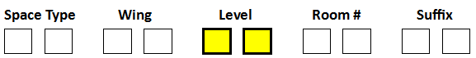
Floors in a building shall be indicated as
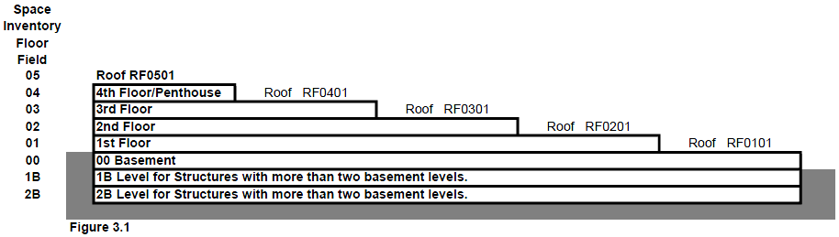

Standard Floors
Standard floors are main levels or stories. Most floors in University buildings will fall in this category. Standard floors should be numbered in ascending order starting with the main or “walk-in” floor and moving upward. Space database codes for these floors should use the leading zero for floors 1 through 9 (ie. 01, 02…09, 10, 11, etc.), however drawing plan room numbers, key drawings & rooms signage for Wayfinding purposes on the 1st through 9th floors should drop the leading zero for the floor level. (ie. 1, 2 …..8, & 9). The titles for the Floor Plans should read - 1st Floor, 2nd Floor, etc.

Ground Floors
Except for existing facilities and/or an addition to an existing facility, the term ‘Ground Floor’ is not to be used.

Basement Floors
Basement floors refer to levels below grade or below the main “walk-in” floor. Basement floors in University buildings should be numbered in ascending order starting with the floor just below the first floor and moving downward. Typically levels accessed by one or more public stair tower(s). Spaces beneath of and in support of one room; and not accessed by a public stair tower are classified as an Interstitial Mechanical Space (see article 6.06).

In cases where there is only one Basement level, the Basement floor number ‘00’ should be used and the label ‘Basement’ will suffice.

In cases where there is more than one basement level the following standard should be used. Plan Room numbers and Space database codes for these floors should be 00, 1B, 2B, 3B, etc. followed by the room number with no hyphen between the level and the room number. Drawing Titles for these floors should be Basement Level 0, Basement Level 1, etc... Note that there are some existing grandfathered in buildings that have ‘00’ for the basement and ‘00’ with an ‘SB’ in front of the room ID indicating it’s in a Sub-Basement. Until there’s a major renovation affecting both levels the room ID will remain unchanged, however for this standard the Sub-Basement floor level becomes 1B for existing buildings.

Elevator buttons shall use ‘B’ for single basements; or ‘B’, ‘1B’, ‘2B’ for multiple basement levels to coordinate with the use of GIS Wayfinding.

Mezzanines
If a building has a partial mezzanine floor above the 1st floor accessible by a public stairs, then the mezzanine is the 2nd floor and the floor above shall be the 3rd floor. In existing buildings where the prescribed standard was not followed, the Mezzanine shall be designated with a floor level of M preceded by the floor level that it is accessed from.

Roofs
The ‘RF’ prefix is used for the LEVEL designation for Roof plans on buildings. Roof Sections are defined on the roof plan and are used to define the net square footage per area. The roof area section numbers are used to identify differing materials, levels and/or drainage.
Roof area sections are numbered in the following order:
- LEVEL = RF
- ROOM # = level above what the roof covers
Roof areas are labeled next (in the ROOM # spaces) to indicate the level that the roof covers. Roof sections that cover level 2 will be on level 3. When a multi-story building has roofs at multiple levels, the roof areas are to be numbered with levels as shown on the above Figure 3.1.
- SUFFIX = roof section number
Section number for each roof area (in SUFFIX spaces). The numbers in the last two spaces do not duplicate. Roof Section number order shall be:
  - Largest roof areas is first
  - Continue largest to smallest and west before east
Example: Roof Plan section numbers are shown for roof area on Level 3 (over level 2), roof section 4.
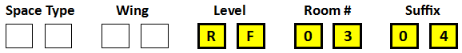

4.0 ROOM NUMBERING:
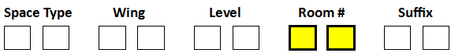

4.1 - Room Numbering: A room numbering system for a building shall use the Floor Level as described in 3.0 above, the room number (00-99) plus applicable prefixes and suffixes. Room number 00 is reserved for the main unassignable public corridors in a building. Corridors within a suite are assignable spaces and shall not use century numbers for their numbering but be subsets of the door leading into the suite. (See 6.1 for examples). DO NOT use periods, hyphens, or spaces in room numbers on the floor plans (see Lab Benches for one exception).

Interior Spaces – Include all floored areas except for those with less than a 3 foot ceiling height. Also include within the room numbering scheme any fully excavated basement areas, interstitial space (i.e., mechanical floor or walkways) mezzanines, penthouses and floored attics meeting the 3 foot minimum ceiling height requirement. Do not include unexcavated basement areas.

Exterior Spaces – four digit number sequence based upon the floor (i.e. XA0101, XA0102, XA0201, XA0202, etc…) for covered areas, whether walled or not, provided they are either within the outside face lines of the buildings to the extent of the roof drip line, or if covered, to the extent of their cover’s drip line. (Walkways, pedestrian bridges, porches, porte-cocheres, loading docks, inner or outer balconies to the extent of a drip line from a roof or balcony immediately above and patio’s beneath building overhangs. The prefix “XA” is to be used only for the exterior covered spaces.

NOTE: Exterior spaces as defined above count as part of the Gross Square Footage (GSF) of the facility and as part of the unassignable area of the facility for University space inventory purposes. These exterior spaces DO NOT count towards GSF used by Kentucky Building Code for code review.
4.2 Organization:
Each facility’s room numbering system shall be structured so that the numbers flow through the building in a consistent and comprehensible pattern. The patterns shall be clear to the users of the facility, not causing confusion for individuals attempting to locate spaces.

Rooms in similar locations on different floors shall have similar room numbers so that room numbers are coordinated on a vertical basis (stacked rooms) as well as a horizontal basis throughout the entire building. To the greatest extent possible, without creating other inconsistencies, rooms with the same digits in the last positions shall be located in the same position in the building. Thus 0001, 0101, 0201, etc., occur in a vertical stack. If two sections of the same floor level are separated from one another at opposite ends of a building, then their vertical numbering scheme shall be similar to the spaces that they are stacked above. Thus rooms 202 to 214 would be above 102 to114 and 278 to 288 would be above 178 to 188 even though there is no floor or rooms between 214 and 278. An effort shall be made to maintain consistent room numbers for similar elements on each floor (i.e., if restrooms, electrical closets, communication closets, etc. are stacked in the same area of each floor they should share common room numbers (i.e. 0010, 110, 210, 310, 410, etc…)

4.3 Odd & Even, and Skipped Room Numbers:

Room numbers should be assigned so that even numbers are on one side of a corridor and odd numbers are on the other side. Buildings with a north/south main corridor orientation shall have the even numbers on the east side and odd number rooms on the west side of the corridors. Buildings with an east/west main corridor orientation shall have the even numbers on the south side and odd number rooms on the north side of the corridor. In buildings with a circular corridor or race track design, the lowest numbers shall start at an obvious point, such as the elevators or front entrance, and progress in a clockwise direction.

Depending upon the footprint of the floor consider jumping four to six room numbers per column bay on each side of the corridor to allow for future division of large rooms into smaller rooms. In most instances, room numbers on one side of a corridor shall be skipped in order to maintain sequencing with the room numbers on the opposite side of the corridor. Gaps in the numbering will occur so that the numbering sequence across a corridor is always ascending. For example, if there are four rooms on the left before there is a room on the right on the 1st floor, the left-hand rooms would be numbered 101, 105, 109, 111. The right-hand room would be numbered 113 even though it is the first room on that side of the corridor. Skipped numbers allow for future renovations that may convert suites or large spaces into separate or small rooms with additional corridor doors (i.e., spread the numbering system out so that infill numbers are available, based on available space).

5.0 – SUFFIXS
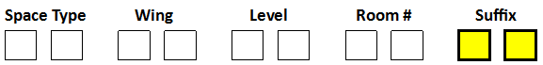
5.1 Suites:
Suites are spaces that generally have one entrance with one primary room and one to many sub-rooms within. Rooms entered directly from a main corridor or lobby receive numbers with no suffix (101, 502, 331, etc.). The entrance room to a suite area gets a typical room number while sub-rooms within the suite are numbered beginning with the main suite room number followed by a letter (alpha) suffix. Rooms within a suite are numbered with the entrance room number plus an alpha suffix (101A, 101B, 101C, etc.) beginning with the room closest to the main entrance and proceeding in a clockwise direction.

Suites are spaces with nested (child to parent) rooms or cubicles (*) within a large (parent) room. In situations where a suite of rooms exists, or rooms have inner rooms, or a room is further subdivided by open landscape office systems or partial height walls, the room numbering shall be such that one number (parent) is used for the main room of the space and the interior rooms (child) will use the main number with an uppercase suffix letter.

Corridors within a lockable/secure suite are assignable spaces and should not use public corridor century numbers (100, 200, 300, etc.) for their numbering but be subsets of the door leading into the suite.

DO NOT USE alphabetical suffix’s ‘I’ and ‘O’ as they will be confused with numbers one and zero.

Example 1:
On a floor of a typical linear building you may have Rooms 201 through 299 along a long corridor with even room numbers on the right and odd room numbers on the left. If you are looking for Room 238 and one begins at the end of the corridor near Room 201, one would know to walk to the other end of the corridor. If you are looking for Room 238A, one would know that the room is nested (child to parent) within Room 238. If you are looking for 238A1, one would know that the room is nested (child to parent) within Room 238A.
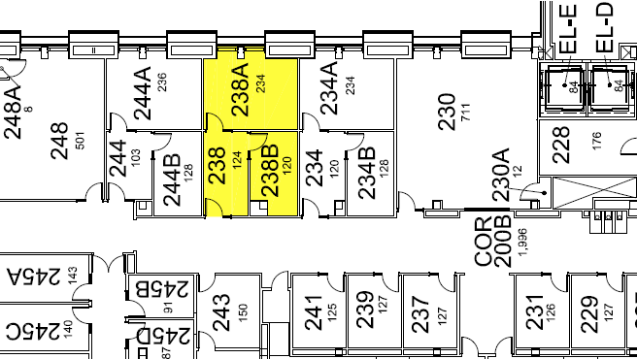

Example 2:
The suite of rooms below show how it is difficult to find rooms numbered 237 through 259A as they are entered thru room 202 and their room numbers are not visible from the main corridor. The rooms off of 202 should have been renumbered when the existing configuration of rooms was renovated into a suite. For correct room numbers and wayfinding, refer to the room numbers in red (202A, 202B, 202C, 202D….202H). Room 259A should be renumbered to 202H1 as it is accessed and nested within what should be 202H.

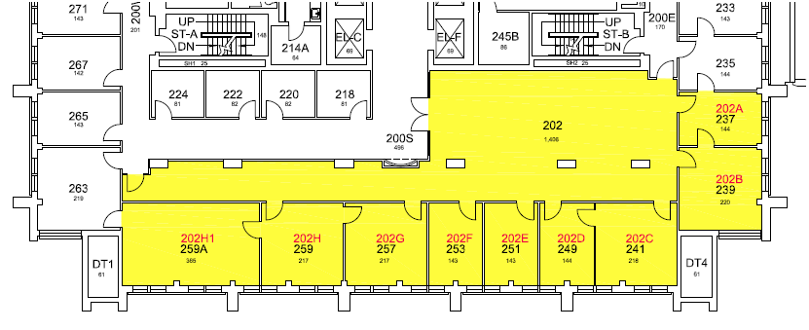
* - "Cubicles are defined as areas separated by partial height walls and or prefabricated systems furniture panels. The use of book cases and desks do not make up a cubicle."
The determining factors as to whether to assign a room number to open office cubicles or workstations are:
- Workstation is hard wired for electrical and communications
- Workstation is for one FTE (**) person as their normal working space equaling or exceeding 80 net assignable square feet (NASF)
- Workstation in the open office area has cubicle walls (soft or hard surface) that are 42” tall or higher.
If all three conditions are met, then room numbers should be assigned. Other situations will be reviewed on a case by case basis.

** - Per the Provost’s Office Standards, 80 net assignable square feet (NASF) is what a Faculty (Consulting, Visiting or active Emeritus); a Lecturer, Fellow, Research Assoc.; a Manager; or a Professional Technical Support Staff would have if they were assigned an Open Workstation.

Consult the Space and Facility Records Manager for designs with irregular patterns or designs not listed here.

6.0 NUMBERING CONVENTIONS FOR SPECIFIC SPACES:

6.01 Corridors: All public unassignable corridors shall be identified using the century numbers 000, 100, 200, 300, etc. with 000 being used for the basement (1B-000 & 2B-000 if more than one basement level), 100 for the first floor, 200 for the second and so on for the remaining upper floors. A suffix shall be used for floors with multiple corridors (i.e. 100A, 100B, 100C, etc.) and suffixes may be used to identify location of the corridors (i.e. 100W for the west corridor and 100E for the east corridor. If a building is divided into zones, such as a wing or a large facility with more than 100 numbered spaces, both a suffix and a prefix may be used to identify the corridors (i.e. a wing of an addition has been assigned a prefix of “F” then the west corridor shall be F-100W). Corridors within a suite are assignable spaces and shall not use century numbers for their numbering but be subsets of the door leading into the suite.

6.02 Ducts: Noted on Key Drawings, KD Excel file, eBARs / SAP as defined below and should be numbered sequentially (i.e. SH1, SH2, SH3,...).. No signage required.
Use | Key Drawing | KD Excel | eBars Data | SAP Functional Location | Room Signage | Floor | Floor Level
YYY | DT1 | DT1 | DT3B01 | DT3B01 | None | Bsmt. Level 3 | 3B
 | DT1 | DT1 | DT2B01 | DT2B01 | None | Bsmt. Level 2 | 2B
 | DT1 | DT1 | DT1B01 | DT1B01 | None | Bsmt. Level 1 | 1B
 | DT1 | DT1 | DT0001 | DT0001 | None | Bsmt Level | 00
 | DT1 | DT1 | DT0101 | DT0101 | None | 1st Floor | 01
 | DT1 | DT1 | DT1M01 | DT1M01 | None | Mezzanine (exist. only) | 1M
 | DT1 | DT1 | DT0201 | DT0201 | None | 2nd Floor | 02
 | DT1 | DT1 | DT1001 | DT1001 | None | 10th Floor | 10
 | DT1 | DT1 | DT2001 | DT2001 | None | 20th Floor | 20

6.03 Dumbwaiters: Noted on Key Drawings, KD Excel file, eBARs / SAP as defined below. Signage should be at each opening to dumbwaiter.
Use | Key Drawing | KD Excel | eBars Data | SAP Functional Location | Room Signage | Floor | Floor Level
YYY | DW1 | DW1 | DW3B01 | DW3B01 | DW #1 | Bsmt. Level 3 | 3B
 | DW1 | DW1 | DW2B01 | DW2B01 | DW #1 | Bsmt. Level 2 | 2B
 | DW1 | DW1 | DW1B01 | DW1B01 | DW #1 | Bsmt. Level 1 | 1B
 | DW1 | DW1 | DW0001 | DW0001 | DW #1 | Bsmt. Level | 00
 | DW1 | DW1 | DW0101 | DW0101 | DW #1 | 1st Floor | 01
 | DW1 | DW1 | DW1M01 | DW1M01 | DW #1 | Mezzanine (exist. only) | 1M
 | DW1 | DW1 | DW0201 | DW0201 | DW #1 | 2nd Floor | 02
 | DW1 | DW1 | DW1001 | DW1001 | DW #1 | 10th Floor | 10
 | DW1 | DW1 | DW2001 | DW2001 | DW #1 | 20th Floor | 20

6.04 Elevators: All elevators for drawings and database purposes shall be identified with the prefix abbreviation “EL” followed by level and a numerical room number and a single alphabetical character suffix. Number banked elevators left to right (A, B, C, etc.) For databases, the Level portion of the elevator room number shall be expanded to four digits using a leading zero for floor levels 01 to 09. The room number is to match the corridor room number (typically 00). However they may be located off of a Departmental Corridor, in which case the elevator room number shall match the departmental corridor room number. Signage showing the Elevator Prefix and alphabetical character should be adjacent to each elevator door opening.

NOTE: The below UK elevator shaft numerical number is different than the one required by the Elevator Standard which is number coded by the elevator installer into the elevator emergency phone to automatically identify a caller’s building and elevator location if an elevator user becomes stuck or needs emergency assistance. Elevator Standard Example 0045A where the first four digits are the assigned UK building number (in this example McVey Hall) and ‘A’ represents elevator A.

Use | Key Drawing | KD Excel | eBars Data | SAP Functional Location | Room Signage | Floor | Floor Level
WWW | EL-A | ELA | EL3B00A | EL3B00A | Elev-A | Bsmt. Level 3 | 3B
 | EL-A | ELA | EL2B00A | EL2B00A | Elev-A | Bsmt. Level 2 | 2B
 | EL-A | ELA | EL1B00A | EL1B00A | Elev-A | Bsmt. Level 1 | 1B
 | EL-A | ELA | EL0000A | EL0000A | Elev-A | Bsmt. Level | 00
 | EL-A | ELA | EL0100A | EL0100A | Elev-A | 1st Floor | 01
 | EL-A | ELA | EL1M00A | EL1M00A | Elev-A | Mezzanine (exist. only) | 1M
 | EL-A | ELA | EL0200A | EL0200A | Elev-A | 2nd Floor | 02
 | EL-A | ELA | EL1000A | EL1000A | Elev-A | 10th Floor | 10
 | EL-A | ELA | EL2000A | EL2000A | Elev-A | 20th Floor | 20

6.05 Exterior Rooms: Exterior Rooms are covered areas, whether walled or not, provided they are either within the outside face lines of the buildings to the extent of the roof drip line, or if covered, to the extent of their cover’s drip line. (ie. walkways, pedestrian bridges, porches, porte-cocheres, loading docks, inner or outer balconies to the extent of a drip line from a roof or balcony immediately above and patios beneath building overhangs. No signage required.

Use | Key Drawing | KD Excel | eBars Data | SAP Functional Location | Room Signage | Floor | Floor Level
WWW | XA01 | XA01 | XA1B01 |  | None | Bsmt Level 1 | 1B
 | XA01 | XA01 | XA0001 |  | None | Bsmt Level | 00
 | XA100 | XA100 | XA0100 |  | None | 1st Floor | 01
 | XA1M01 | XA1M01 | XA1M01 |  | None | Mezzanine | 1M
 | XA200 | XA200 | XA0200 |  | None | 2nd Floor | 02
 | XA1000 | XA1000 | XA1000 |  | None | 10th Floor | 10
 | XA2000 | XA2000 | XA2000 |  | None | 20th Floor | 20

6.06 Interstitial Mechanical Spaces: If a building has interstitial mechanical areas that have floors (either above or below) or catwalks, then the floored spaces in the interstitial space shall have a prefix of ‘NR’ and be numbered so as to assist Wayfinding to that location (ie. A catwalk above room 316 and accessed from room 316 would be NR0316, whereas if the catwalk was above room 316, but accessed from 416, then it would be NR0416 for Wayfinding purposes.) Note that floored interstitial spaces/catwalks count as part of the Gross Square Footage of a facility as well as are part of the un-assignable areas of the facility. (See also 6.13 Tunnel.)

NOTE: Signage only required adjacent to a regular door accessing interstitial space. Otherwise UK Space Inventory’s eBars Bar Code on the hinge side of the jamb will suffice.
Use | Key Drawing | KD Excel | eBars Data | SAP Functional Location | Room Signage | Floor | Floor Level
YYY | NR01 | NR01 | NR3B01 | NR3B01 | See Note: | Bsmt. Level 3 | 3B
 | NR01 | NR01 | NR2B01 | NR2B01 | See Note: | Bsmt. Level 2 | 2B
 | NR01 | NR01 | NR1B01 | NR1B01 | See Note: | Bsmt. Level 1 | 1B
 | NR01 | NR01 | NR0001 | NR0001 | See Note: | Bsmt. Level | 00
 | NR01 | NR01 | NR0101 | NR0101 | See Note: | 1st Floor | 01
 | NR01 | NR01 | NR0201 | NR0201 | See Note: | 2nd Floor | 02
 | NR01 | NR01 | NR1001 | NR1001 | See Note: | 10th Floor | 10
 | NR01 | NR01 | NR2001 | NR2001 | See Note: | 20th Floor | 20

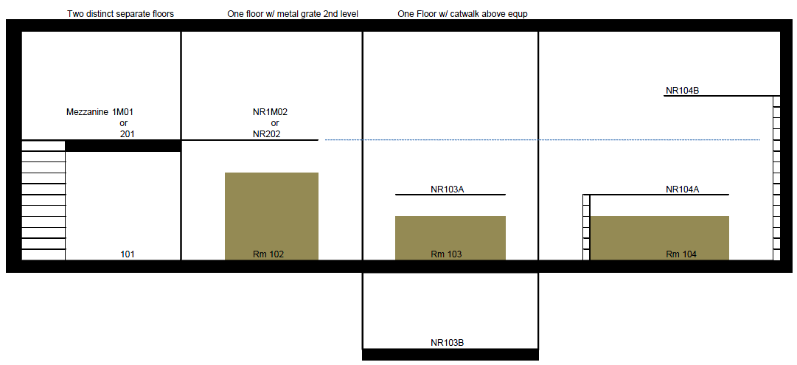
6.07 Lab Benches
Confirm with the Project Manager whether individual lab benches in large Open Plan Labs (for example Biological Biomedical Sciences Research Building (BBSRB)) need to be numbered with the Prefix LB and a 2 digit number. The bench numbers are separate from the room numbers. (ie LBB0206-01 where LB is the prefix, B is the wing, 02 is the level, 06 is the room number, a hyphen, then the bench number) Lab Bench signage is to be provided for each open plan lab bench.

Use | Key Drawing | KD Excel | eBars Data | SAP Functional Location | Room Signage | Floor | Floor Level
 | LB3B01-01 | LB3B0101 | LB3B0101 | LB3B0101 | LB3B01-01 | Bsmt. Level 3 | 3B
 | LB2B01-01 | LB2B0101 | LB2B0101 | LB2B0101 | LB2B01-01 | Bsmt. Level 2 | 2B
 | LB1B01-01 | LB1B0101 | LB1B0101 | LB1B0101 | LB1B01-01 | Bsmt. Level 1 | 1B
 | LB0001-01 | LB000101 | LB000101 | LB000101 | LB0001-01 | Bsmt. Level | 00
 | LB0101-01 | LB010101 | LB010101 | LB010101 | LB101-01 | 1st Floor | 01
 | LB0201-01 | LB020101 | LB020101 | LB020101 | LB201-01 | 2nd Floor | 02
 | LB1001-01 | LB100101 | LB100101 | LB100101 | LB1001-01 | 10th Floor | 10
 | LB2001-01 | LB200101 | LB200101 | LB200101 | LB2001-01 | 20th Floor | 20

6.08 Penthouses
Usable attic floors and penthouse levels should be numbered as if they are whole floors. Example – A two story penthouse above a five story building is numbered as the sixth and seventh floors.

Use | Key Drawing | KD Excel | eBars Data | SAP Functional Location | Room Signage | Floor | Floor Level
YYY | PH400 | PH400 | PH0400 | PH0400 | PH400 | 4th Floor | 04

6.09 Pipe Chase
Pipe chases should be numbered sequentially (i.e. PC1, PC2, PC3,…). Unless there is a full size door accessing the space no signage required.

Use | Key Drawing | KD Excel | eBars Data | SAP Functional Location | Room Signage | Floor | Floor Level
YYY | PC1 | PC1 | PC3B01 |  | None | Bsmt. Level 3 | 3B
 | PC1 | PC1 | PC2B01 |  | None | Bsmt. Level 2 | 2B
 | PC1 | PC1 | PC1B01 |  | None | Bsmt. Level 1 | 1B
 | PC1 | PC1 | PC0001 |  | None | Bsmt. Level | 00
 | PC1 | PC1 | PC0101 |  | None | 1st Floor | 01
 | PC1 | PC1 | PC1M01 |  | None | Mezzanine | M1
 | PC1 | PC1 | PC0201 |  | None | 2nd Floor | 02
 | PC1 | PC1 | PC1001 |  | None | 10th Floor | 10
 | PC1 | PC1 | PC2001 |  | None | 20th Floor | 20

6.10 Shafts
Shafts should be numbered sequentially (i.e. SH1, SH2, SH3,…). Unless there is a full size door accessing the space no signage required.

Use | Key Drawing | KD Excel | eBars Data | SAP Functional Location | Room Signage | Floor | Floor Level
YYY | SH1 | SH1 | SH3B01 |  | None | Bsmt. Level 3 | 3B
 | SH1 | SH1 | SH2B01 |  | None | Bmst. Level 2 | 2B
 | SH1 | SH1 | SH1B01 |  | None | Bsmt. Level 1 | 1B
 | SH1 | SH1 | SH0001 |  | None | Bsmt. Level | 00
 | SH1 | SH1 | SH0101 |  | None | 1st Floor | 01
 | SH1 | SH1 | SH1M01 |  | None | Mezzanine (exist.only) | M1
 | SH1 | SH1 | SH0201 |  | None | 2nd Floor | 02
 | SH1 | SH1 | SH1001 |  | None | 10th Floor | 10
 | SH1 | SH1 | SH2001 |  | None | 20th Floor | 20

6.11 Stairs: All stairs (through each floor in which they pass) for drawings and database purposes shall be identified with a prefix abbreviation “ST” followed by a numerical floor number followed by a numerical room number and a single uppercase letter starting with the letter A (i.e. A, B, C, D, E, etc.). Only one letter shall be used for the entire height of the stairwell. For databases, the number portion of the stair room number shall be expanded to two digits for the Level and ‘00’ as the two digits for the room number.

Use | Key Drawing | KD Excel | eBars Data | SAP Functional Location | Room Signage | Floor | Floor Level
WWW | ST-A | STA | ST3B00A | ST3B00A | Stair-A | Bsmt. Level 3 | 3B
 | ST-A | STA | ST2B00A | ST2B00A | Stair-A | Bsmt.Level 2 | 2B
 | ST-A | STA | ST1B00A | ST1B00A | Stair-A | Bsmt. Level 1 | 1B
 | ST-A | STA | ST0000A | ST0000A | Stair-A | Bsmt. Level | 00
 | ST-A | STA | ST0100A | ST0100A | Stair-A | 1st Floor | 01
 | ST-A | STA | ST1M01A | ST1M01A | Stair-A | Mezzanine (exist. only) | 1M
 | ST-A | STA | ST0200A | ST0200A | Stair-A | 2nd Floor | 02
 | ST-A | STA | ST1000A | ST1000A | Stair-A | 10th Floor | 10
 | ST-A | STA | ST2000A | ST2000A | Stair-A | 20th Floor | 20

6.12 Trash Chutes
Trash Chutes should be numbered sequentially (i.e. CH1, CH2, CH3, …). Unless there is a full size door accessing the space no signage required.

Use | Key Drawing | KD Excel | eBars Data | SAP Functional Location | Room Signage | Floor | Floor Level
YYY | CH1 | CH1 | CH3B01 | CH3B01 | None | Bsmt Level 3 | 3B
 | CH1 | CH1 | CH2B01 | CH2B01 | None | Bsmt Level 2 | 2B
 | CH1 | CH1 | CH1B01 | CH1B01 | None | Bsmt Level 1 | 1B
 | CH1 | CH1 | CH0001 | CH0001 | None | Bsmt Level | 00
 | CH1 | CH1 | CH0100 | CH0100 | None | 1st Floor | 01
 | CH1 | CH1 | CH1M01 | CH1M01 | None | Mezzanine (exist. only) | 1M
 | CH1 | CH1 | CH0200 | CH0200 | None | 2nd Floor | 02
 | CH1 | CH1 | CH1000 | CH1000 | None | 10th Floor | 10
 | CH1 | CH1 | CH2000 | CH2000 | None | 20th Floor | 20

6.13 Tunnels
Note: If a new /existing building constructs a tunnel below the lowest building floor level of that building which will connect to an existing tunnel system, then the new tunnel floor level and room ID is numbered as if it is at the floor level of the existing tunnel. Tunnels (36” or taller) count towards the GSF of a building and are to have a ‘TL’ prefix. Trench tunnels (less than 36” in height) are to have a ‘TN’ prefix and DO NOT count towards the GSF of a building..
Use | Key Drawing | KD Excel | eBars Data | SAP Functional Location | Room Signage | Floor | Floor Level
YYY | TL1 | TL1 | TL3B01 | TL3B01 | TL3B01 | Bsmt Level 3 | 3B
 | TL1 | TL1 | TL2B01 | TL2B01 | TL2B01 | Bsmt Level 2 | 2B
 | TL1 | TL1 | TL1B01 | TL1B01 | TL1B01 | Bsmt Level 1 | 1B
 | TL1 | TL1 | TL0001 | TL0001 | TL0001 | Bsmt Level | 00
 | TL1 | TL1 | TL0100 | TL0100 | TL0100 | 1st Floor | 01

6.14 Parking Structures: The room numbers selected for rooms in parking garages shall correspond to the designated garage levels as shown on the plans. For example, a storage room located on the second level of a garage will have a number between 200 and 299. Office suites in garages will follow the standards for buildings as previously described.
7.0 APPROVALS:

All room numbers must meet the approval of the University’s Space and Facility Records Manager’ and/or his/her designated reviewer. If there is any deviating from these standards, it requires the approval of the Space and Facility Records Manager (or his/her designated representative) and input is required from the UK Space Inventory/PM database programmers to be sure that what’s being proposed is feasible/possible from the university’s database side.

